4 Kinds of Clouds

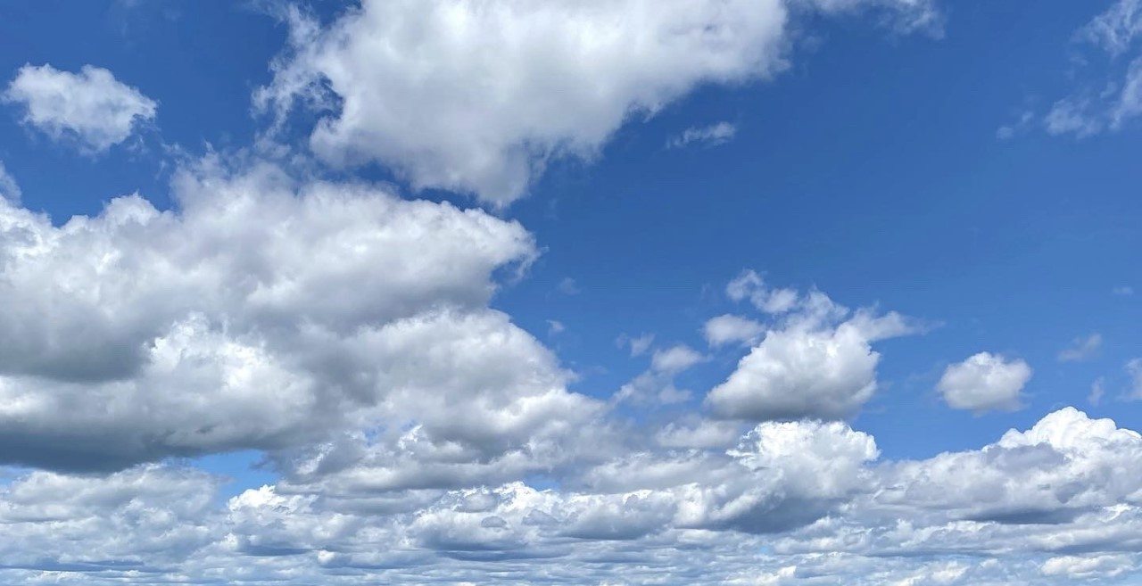

Cumulus

(Pronounced: Qum-Mew-Luss)

Clouds with puffy, flat bottoms that are low in the sky. They usually mean the weather will be nice!

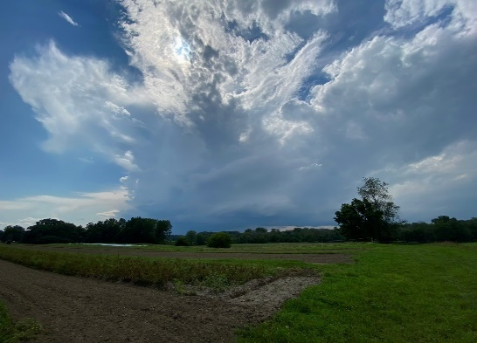

Cumulonimbus (Pronounced: Cuem-Mew-Low-Nim-Bus)

These are thunderstorm clouds. They look like very tall cumulus clouds but often are darker in color.

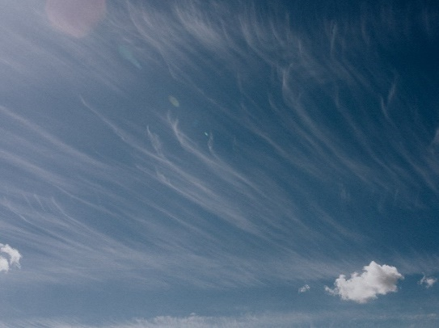

Cirrus

(Pronounced: Sear-us)

Thin, white clouds that are very high in the sky. They are made of ice crystals and are a sign of nice weather.



Stratus

(Pronounced: Strat-Us)

Clouds that are wide blankets or layers of clouds. They are low in the sky and they are often a sign of rain!