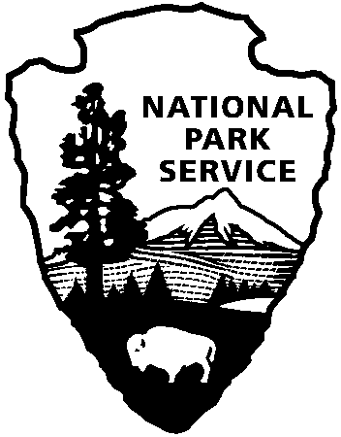
9800 Black Rock Canyon Rd.
Yucca Valley, CA 92284

For questions:
760-367-3012
jotr_education@nps.gov
Joshua Tree National Park
Education Office
National Park Service
U.S. Department of the Interior

Transportation Funding Request

Directions:

download document, complete and save, email the completed copy along with Field Trip Request to: jotr_education@nps.gov

Teacher Contact: teacher name Email: teacher email School Name: school name
Field Trip Date: 1st Choice: mm/dd/yy

*Cost Estimate: enter dollar amount

*Please obtain the most accurate estimate from your bus company using the distance between your school and the Field Trip location. All locations are easily found on Google maps. Because of the significant delay in time between the field trip and receipt of the bill, inaccurate estimates will negatively affect our record keeping, in turn, potentially causing us to cancel future field trips because of lack of funds. There is a very small margin of error we will accept between the estimate and actual cost, approximately 15% over estimate provided.

*Accuracy is especially important since a new company is now providing bus service and old estimates are no longer reliable.

*For questions/assistance, please call 760-367-3012.

*Bus funding is NOT GUARANTEED and will not be provided without a Transportation Funding Request. Subsidies are dispersed on a first come-first served basis until all funds are exhausted.
OFFICIAL USE ONLY
Date Received
Approved/Denied
Added to stats

