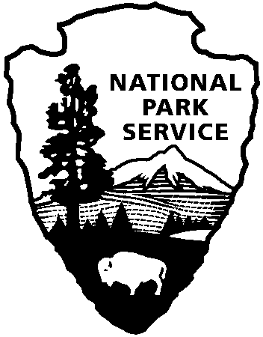
9800 Black Rock Canyon Rd.
Yucca Valley, CA 92284

For questions:
760-367-3012
jotr_education@nps.gov
Joshua Tree National Park
Education Office
National Park Service
U.S. Department of the Interior

Field Trip Reservation Request

Directions:

download document, complete and save, email the completed copy to: jotr_education@nps.gov

Teacher Contact: teacher name Email: teacher email School Phone: phone number

School: school name school address
Participating Teachers: names of participating teachers

*Most program locations can accommodate one school bus (two classes per bus). For two busses, plan on two days for your field trip. Park staff will work with you to schedule the extra day from the dates you provide below.

Date: 1st Choice: mm/dd/yy 2nd Choice: mm/dd/yy 3rd Choice: mm/dd/yy

Program Requested: Program Title, select from updated list on website
Grade: grade level Number of Classes: total # Number of Students: total #
Number of Chaperones: 10:1 ratio requested Number of Chaperone vehicles: # extra cars

What time will you leave the school? time Time to be back at school? time
Est. Arrival Time at Park: time

Teacher’s Goals for Students: ex. We are learning about the rock cycle
Special Accommodations Needed: comments
OFFICIAL USE ONLY
Date Received
Added to Calendar
Confirmation Emailed
Notified Staff

*Transportation subsidies are available. Please complete a “Transportation Funding Request” and submit it with this form. Bus funding is NOT GUARANTEED and will not be provided without an accompanying Transportation Funding Request. Subsidies are dispersed on a first come-first served basis until all funds are exhausted.

