2021 Glacier Bay Christmas Bird Count Results
Nat Drumheller

The 49th Glacier Bay Christmas Bird Count was on 18 December 2021. Twenty-six people participated. Fifty-one species were found on count day. An additional 14 species were found during count week for a count week total of 65. A list of the birds with their numbers is at the end.

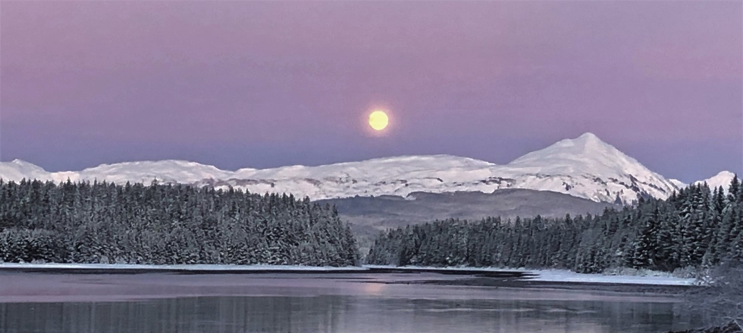
Afternoon moon over Bartlett Cove, 18 December 2021 -Nat Drumheller

Count day was described by many participants as “beautiful and cold”. It was partly sunny with light winds out of the Northeast. Two feet of snow in open areas made getting around challenging. At least five of the field parties were on skis or snow shoes to bird along the town beaches, in the Crane Flats, and at the Bartlett River mouth. The temperature in town ranged from 3 to 18 degrees F. It was warmer on the Glacier Bay side where it likely stayed around 15 degrees. Visibility on the saltwater along town was poor due to fog. Visibility on the water in lower Glacier Bay was excellent. Ponds were frozen and streams were partly frozen. The weather in November and December leading up to the count can be summed up as snowy! It did not get really cold until the week of the count.

None of the birds found on count day were unexpected, but there were some nice finds. 62 Trumpeter Swans ties the record CBC high count. Two of these were on the Salmon River and the rest were at the Bartlett River mouth. 280 Snow Buntings is one of the higher counts in our CBC, but not in the top three. These were in the beach grasslands east of the town dock. 23 Black Turnstones in the Beardslee Islands is only the second time this species has been found on count day and is the record high of the two counts. Small numbers of Black Turnstones may regularly winter in Glacier Bay, but there are not many reports. Common Goldeneye and Red-necked Grebe both had record high counts by small margins. Both were found only on the Glacier Bay side on count day. A continuing European Starling and a continuing Varied Thrush were good finds in town near Dock Road. 3 Double-crested Cormorants and 2 Peregrine Falcons were seen in lower Glacier Bay.
There were 14 count week species. These are birds that were not found on count day but were found during the three days on either side of count day. Three of these, Golden-crowned Kinglet, American Wigeon, and Gadwall, were the biggest misses on count day. The other count week species were Northern Pintail, Northern Goshawk, Northern Harrier, Northern Flicker, Northern Shrike, Pine Siskin, Brown Creeper, White-throated Sparrow, White-winged Crossbill, American Dipper, and Great Horned Owl. There were relatively few dabbling ducks seen on count day. Owls of any kind were almost missed during the entire count week but a dueting pair of Great Horned Owls were heard east of town near Rink Creek.

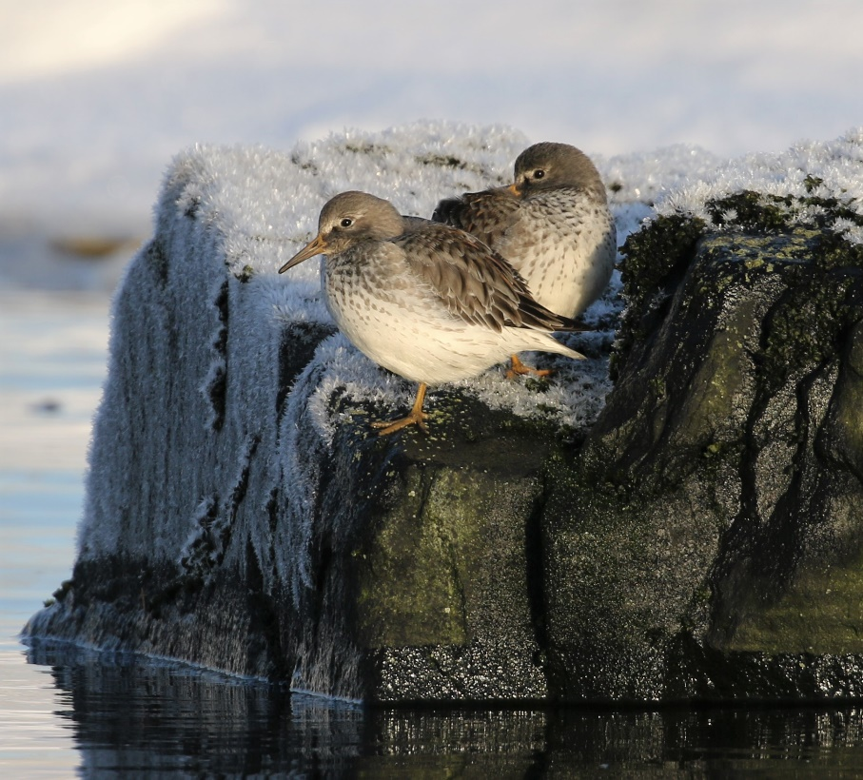
Rock Sandpipers, Beardslee Islands 18 December 2021 -Nat Drumheller

The first Glacier Bay Christmas Bird Count was in 1968. Generally, the farther back you go the lower the number of species found on count day. This is likely due to increasing participation over the years. This year’s count day species tally of 51 is the lowest since 1985. The cold and snow made it clear this was not going to be a record breaking bird count. And it was quiet. A reduction in the area covered this year was also a factor in the low numbers. Fog on the water along the town beaches foiled efforts to see birds there. No one walked around Point Gustavus due to the snow and a mid-day high tide. That route is productive. Thanks to Lewis Sharman we did have a skiff birding in Bartlett Cove, Sitakaday Narrows, and the lower Beardslee Islands. With no National Park Service boat, the Icy Strait portion of the count was not covered. No large concentrations of birds were seen in the lower bay. A large number of gulls could be seen over the water in Icy Strait toward Lemesurier Island, but they were not part of our count.

As you know, the names of birds are sometimes changed. This is now often the result of genetics research which leads to the splitting of some species and the lumping of others. Two recent examples are Mew gull and Northwestern Crow. Mew Gull was split into the Eurasian species (Common Gull) and the American species (Short-billed Gull). Northwestern Crow was lumped with American Crow. Our crows are now considered American Crows. Years ago Winter Wren was split with the eastern species retaining the name Winter Wren and the western species becoming Pacific Wren. And so it goes.
18 December 2021 Glacier Bay CBC Species List
The species order follows the 27th edition 2021 Checklist of Alaska Birds.
cw = count week (15-21 December 2021)
Species | Count |  | # Years/% Years | High Count-Year
 |  |  | on Count Day
Canada Goose | 244 |  | 49/100% | 635-1982
Trumpeter Swan | 62 | Tied for record high count | 27/55% | 62-2018
Gadwall | cw |  | 35/71% | 72-1987
American Wigeon | cw |  | 47/96% | 141-1974
Mallard | 446 |  | 49/100% | 1700-2017
Northern Pintail | cw |  | 27/55% | 86-1998
Green-winged Teal | 37 |  | 42/86% | 159-1997
Greater Scaup | 32 |  | 31/63% | 63-1998
Harlequin Duck | 78 |  | 49/100% | 190-1998
Surf Scoter | 931 |  | 49/100% | 4798-2018
White-winged Scoter | 510 |  | 49/100% | 2404-1989
Black Scoter | 16 |  | 41/84% | 600-2018
Long-tailed Duck | 41 |  | 49/100% | 1634-1983
Bufflehead | 226 |  | 49/100% | 294-2005
Common Goldeneye | 50 | Record high count | 48/98% | 43-2010
Barrow's Goldeneye | 393 |  | 49/100% | 878-2002
Common Merganser | 37 |  | 48/98% | 245-2002
Red-breasted Merganser | 221 |  | 49/100% | 412-2005
Horned Grebe | 90 | 2nd highest count | 49/100% | 111-2014
Red-necked Grebe | 61 | Record high count | 45/92% | 58-2017
Black Oystercatcher | 13 |  | 12/24% | 33-2017
Black Turnstone | 23 | High count, 2nd time on count day | 2/4% | 4-2005
Sanderling | 30 |  | 40/82% | 611-1987
Dunlin | 200 |  | 18/37% | 2100-2010
Rock Sandpiper | 30 |  | 45/92% | 3390-1998
Common Murre | 242 |  | 49/100% | 5023-1989
Pigeon Guillemot | 160 |  | 49/100% | 753-1992
Marbled Murrelet | 722 |  | 49/100% | 1478-1992
Short-billed Gull | 805 |  | 49/100% | 2810-2019
Glaucous-winged Gull | 171 |  | 49/100% | 1150-2019
Red-throated Loon | 11 |  | 38/78% | 26-1970
Pacific Loon | 62 |  | 46/94% | 405-2017
Common Loon | 23 |  | 49/100% | 105-2007
Pelagic Cormorant | 62 |  | 49/100% | 195-2005
Double-crested Cormorant | 3 | 2nd highest count | 17/35% | 6-1983
Great Blue Heron | 21 |  | 43/88% | 39-2019
Northern Harrier | cw |  | 11/22% | 4-2007
Northern Goshawk | cw |  | 20/41% | 3-1999
Bald Eagle | 33 |  | 49/100% | 83-1977
Great Horned Owl | cw |  | 7/14% | 2-1985
Belted Kingfisher | 5 |  | 40/82% | 12-2005
Downy Woodpecker | 1 |  | 18/37% | 3-2006
Species | Count |  | # Years/% Years | High Count-Year
 |  |  | on Count Day
Northern Flicker | cw |  | 10/20% | 3-2005
Peregrine Falcon | 2 | Tied for record high count | 14/29% | 2-3 years
Northern Shrike | cw |  | 29/59% | 4-2015
Steller's Jay | 1 |  | 40/82% | 29-2015
Black-billed Magpie | 17 |  | 49/100% | 59-2004
American Crow | 184 |  | 49/100% | 542-2000
Common Raven | 30 |  | 49/100% | 103-2005
Chestnut-backed Chickadee | 114 |  | 47/96% | 273-2017
Red-breasted Nuthatch | 2 |  | 24/49% | 47-2004
Brown Creeper | cw |  | 20/41% | 8-2017
Pacific Wren | 1 |  | 34/69% | 31-2019
American Dipper | cw |  | 28/57% | 3-2016 & 2019
Golden-crowned Kinglet | cw |  | 42/86% | 101-2005
Varied Thrush | 1 |  | 17/35% | 25-2014
European Starling | 1 |  | 11/22% | 20-2000
Pine Grosbeak | 3 |  | 35/71% | 50-1969
White-winged Crossbill | cw |  | 28/57% | 2380-2002
Pine Siskin | cw |  | 32/65% | 1600-2014
Snow Bunting | 280 |  | 43/88% | 715-1975
American Tree Sparrow | 2 |  | 39/80% | 38-2009
Dark-eyed Junco | 74 |  | 44/90% | 497-2019
White-throated Sparrow | cw |  | 4/8% | 1-4 years
Song Sparrow | 14 |  | 44/90% | 53-2019
duck sp. | 80 |  | - | -
goldeneye sp. | 18 |  | - | -
scoter sp. | 70 |  | - | -
merganser sp. | 9 |  | - | -
shorebird sp. | 100 |  | - | -
gull sp. | 648 |  | - | -
siskin/redpoll | 3 |  | - | -
songbird sp. | 5 |  | - | -
Count Day Species Total | 51 | (52 with siskin/redpoll sp.)
Count Week Species Total | 65

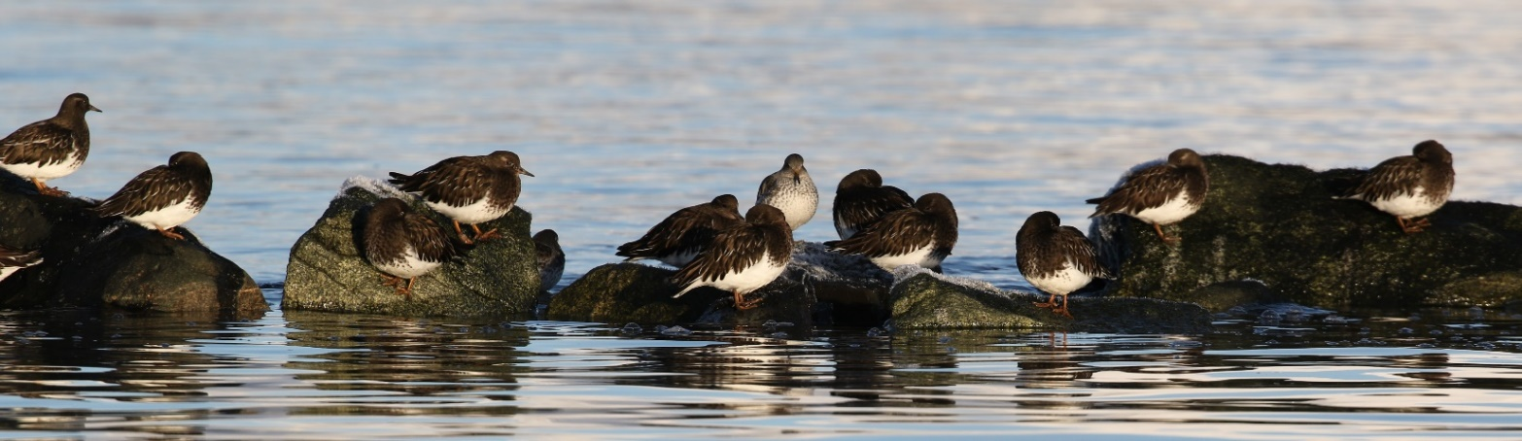
Black Turnstones and a Rock Sandpiper, Beardslee Islands 18 December 2021 -Nat Drumheller

