WILDERNESS VISITOR USE MANAGEMENT PLAN

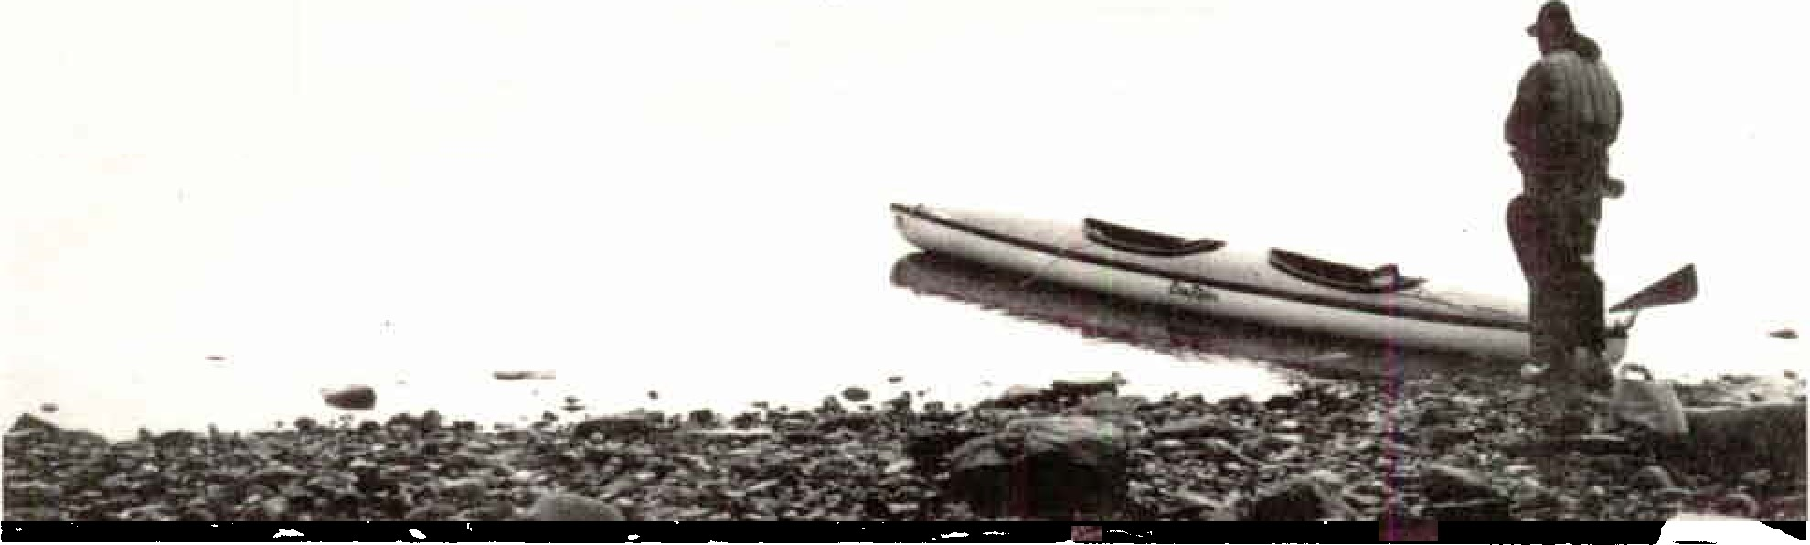

GLACIER BAY NATIONAL PARK & PRESERVE JULY 1989

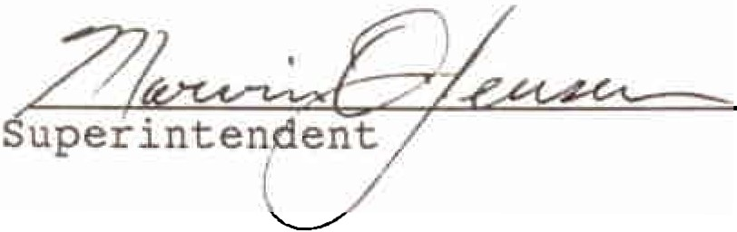Approved by:

Date: July 12, 1989

TABLE OF CONTENTS

I. INTRODUCTION . . . . . . . . . . . . . . · • • 1
A. PURPOSE AND SCOPE . . . . . . . . . . • • • • • • • 1
- WILDERNESS MANAGEMENT OBJECTIVES . . . • · • • 2
- LEGAL CONSIDERATIONS . . . . . . . . . · • • · • · 3
  - National Monument Proclamation. . ....·· 3
  - National Park Legislation ........·· 3
  - Wilderness Designation .........····· 4

- WILDERNESS MANAGEMENT
  - WILDERNESS ZONES

. . . . . . . . . . . . . . . . . . 6

. . . . . . . . . . . . . . . . 6
.

    - Resource Conditions . . . . . . . . .. . . 6
    - Social Conditions . . . . . . . . · · · · 7
    - Management Conditions ..........···· 7
B. FACILITIES . . . . . . . . . . . . . . . • · · • • • • 8
- Visitor Facilities ...........· 8
- Administrative Facilities . . . . . • · · · · 8
C. ACCESS . . • • . • . . . . • · · • • • • · 8
D. VISITOR MANAGEMENT . . . . . . . . • • 9
1. Group Size. . . . . . . . . . . . · · · · 9
2. Group Spacing ..............···· 9
3• Stay Limit . . . . . . . . . . . . . . • · · · 10
- Orientation and Registration. . ... • · · · 10
- Regulations and Closures ........ . 10
E. GUIDE ACTIVITY . . . . . . . . . . . . . . . • · · 11
- Sea Kayaking Guide Service - Glacier Bay Proper 11
- Backpacking/ Hiking ........ . 11
- Mountaineering/ Ski Touring ...... 12
- Other Authorized Guide Services .. . 13
F. RESOURCE MANAGEMENT . . . . . . . . . . . . . · • · 13
1. Resource Inventory ............· • · · 13
- Campsite Monitoring .......... 13
- Carrying Capacity Study . . . . . . . · · · · 15
G. BEAR MANAGEMENT. . . . . . . . . . . . . . • • • • 15
- Education and Enforcement ....... 16
- Reduction of Unnatural Food Sources ... • • 16
3. Closures ..•..............• · 16
4. Statistics and Monitoring ........· • 17
H. RESEARCH . . . . . . . . . 17
- CONSISTENCY WITH OTHER PARK PLANS, USES 18
- FUTURE ACTIONS/ PLAN UPDATE . . . . . . . . . . . 20
V. APPENDIX . . . . . . . . . . . . . . . . . . . . . . . . 21
  - CAMPSITE SURVEY FORM • . . . . . . • . . • . . . . . . 21
  - BACKCOUNTRY REGISTRATION FORM ........ , . . 22
  - MINIMUM IMPACT CAMPING GUIDELINES ...... , . . 23
  - ANNUAL WILDERNESS OPERATING PLAN .... , . • • • 24

- INTRODUCTION

- PURPOSE AND SCOPE
The purpose of this plan is to establish management strategies that minimize the impacts of humans and their technology upon the wilderness resource of Glacier Bay National Park, while allowing types and amounts of use appropriate in a wilderness setting.
Park management will seek to preserve the natural and aesthetic values that assure the opportunity for solitude, and that permit ecosystems to function without significant human intervention.
The draft National Park Service (NPS) management policy on wilderness preservation and management stated that:
"The manager of each park area ..• shall develop and maintain a wilderness management plan to guide the preservation, management and use of that wilderness. This plan shall ... address the preservation of wilderness-dependent physical, biological and sociological values. Where necessary for the preservation of wilderness resources or values the NPS shall determine carrying capacities and, where resource impacts or use demands exceed established thresholds or capacities, may limit or redirect use. General regulations, special regulations and permit systems, as well as local restrictions, public use limits, closures and designations implemented under the discretionary authority of the superintendent are all appropriate tools for use in managing and protecting wilderness."

The Glacier Bay Wilderness Visitor Use Management Plan covers visitor use and activities in designated wilderness lands and designated wilderness waters within the park except the Alsek River watershed (which is managed under a separate plan). The plan also covers the only two parcels of land in Glacier Bay National Park outside the Bartlett Cove area and Alsek River watershed which are not currently designated wilderness (island in Blue Mouse Cove and Cenotaph Island in Lituya Bay). Also, the plan does not include the 57,800 acre Glacier Bay National Preserve, none of which is designated wilderness (Figure l).
This plan concerns visitor use management only. Other issues, such as mining, commercial fishing, research, etc. are not covered and not within the scope of this plan, as they have particular legal contexts that are best described in separate documents.

1

THE REGION
GLACIER BAY NATIONAL PARK AND PRESER VE

o..-,
GLACIER BAY
NATIONA L PARK

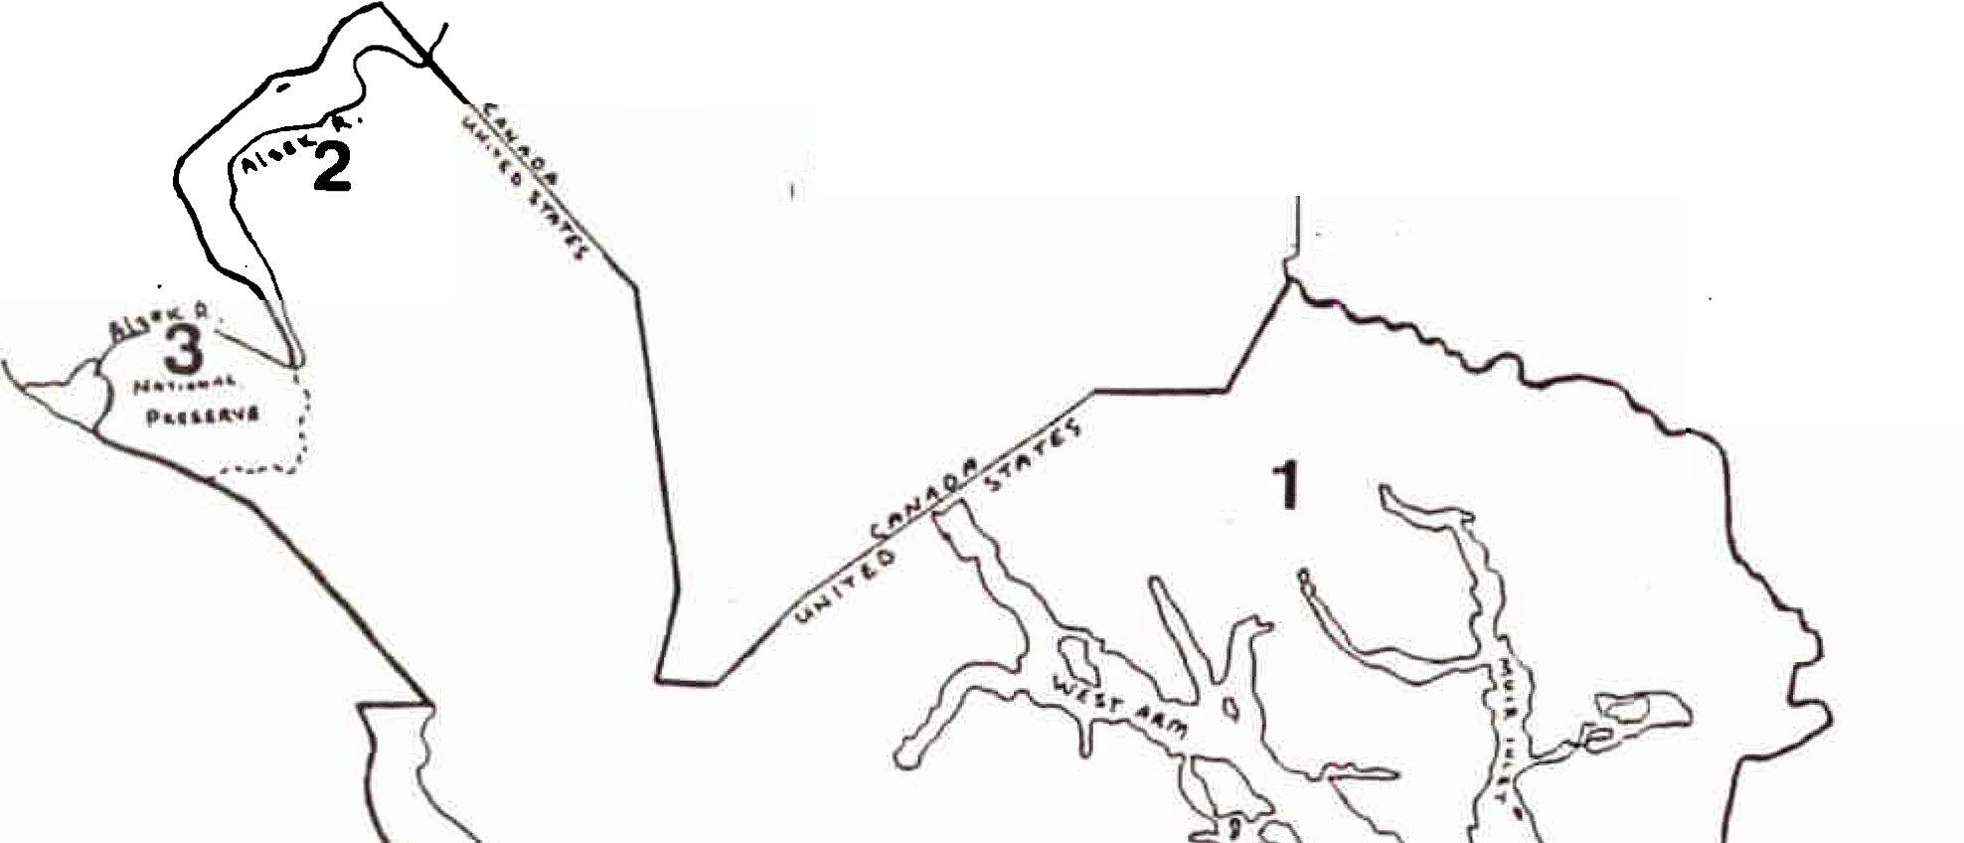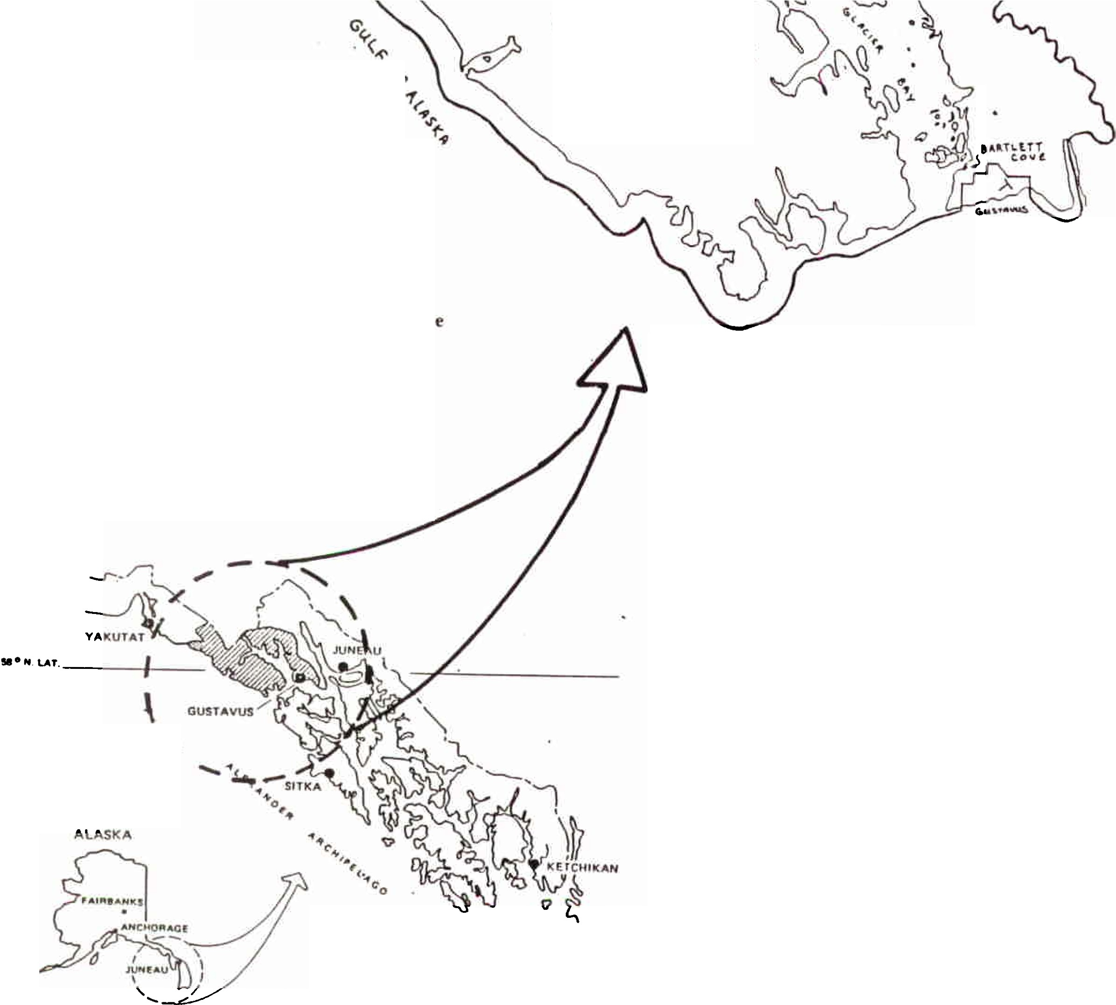

f ig ure 1

  - Glacier Ba y Wllderness

  - Alsek River Watershed

  - Glacier Bay National Preserve

I
\

I

'

The plan is consistent with, and subsidiary to, the park-wide general management plan which was approved in September 1984 (See Sec. III, Consistency with other park plans). The wilderness visitor use management plan presents the general concepts which are expected to guide visitor use for the next 5 to 10 years. An annual operating plan in the appendix includes detailed information that is subject to change on a more frequent basis.

The draft version of the Glacier Bay Wilderness Visitor Use Management Plan, dated May 1988, was available for public comment from June 3 through August 31, 1988. Late comments were accepted until January 1989. Public meetings on the plan were held in Gustavus (6/27/88), Juneau (6/28/88), and Yakutat (7/21/88).
Fifteen - twenty letters concerning the plan were received by the park and are available for review at Bartlett Cove.
The plan meets the National Environmental Policy Act requirements for a categorical exclusion (516 OM 6, Appendix 7, sec. 7.4 B (1)) and no further environmental documentation has been prepared.

B# WILDERNESS MANAGEMENT OBJECTIVES
Glacier Bay National Park and Preserve is managed in accordance with existing legislative mandates (National Park Service Act of 8/25/16, Wilderness Act of 1964, ANILCA of 1980, etc.) and National Park Service Management Policies. Recreational use will be managed consistent with the overall management objectives of the park, preserve and designated wilderness. These objectives are listed in the Glacier Bay General Management Plan and are incorporated in this subsidiary plan by reference.

The key to preservation of the flora and fauna is protection of ecological process and allowing them to freely function with minimal influence of man’s activities. Setting use lev ls such as group sizes, etc. along with guidelines for proper camping related activities are primary ways of ensuring that these processes are allowed to operate with minimal disturbance.
Keeping careful watch on visitor use activities and their effects on the naturally functioning ecosystems is essential to keeping the use levels and guidelines current. Also in this plan, efforts are made to provide areas where a high quality wilderness experience is available to wilderness users. When human activity adversely affects the wilderness experience or resource integrity, management action will be necessary to keep that effect within acceptable limits.
The objectives of this wilderness management plan are to:
    - Allow ecological processes to continue unimpaired by
Visitor activities

2

    - Preserve opportunities for outstanding aquatic and terrestrial wilderness experiences.
    - Protect specific sensitive species of wildlife and vegetation from adverse effects of visitor use.
    - Provide opportunity for visitors to gain a greater understanding of the park resources and values to help heighten their enjoyment of their visit.

    - Minimize the effects that motorized uses such as aircraft and motor boats may have on wilderness values and experiences.
    - Develop a greater understanding through research, of those issues that are important to the other objectives mentioned above.
    - Monitor and evaluate the effects of the management program to provide information for modifications.
    - Make adjustments/modifications in the management program as needed based on monitoring and research information and public review and comment.

- LEGAL CONSIDERATIONS
  - National Monument Proclamation
Glacier Bay National Monument (now included in the National Park) was established in 1925 by presidential proclamation. The purpose of the monument was to preserve an area significant for:

a number of tidewater glaciers of the first rank in a magnificent setting of lofty peaks.
a great variety of forest covering consisting of mature areas, bodies of youthful trees which have become established since the retreat of the ice which should be preserved in absolutely natural condition.
a unique opportunity for the scientific study of glacial behavior and of resulting movements and developments of flora and fauna.
  - National Park Legislation
On December 2, 1980 Congress passed the Alaska National Interest Lands Conservation Act (ANILCA) expanding the park boundaries,
most of the area as wildernes, creating a National
3

Preserve and providing additional National Park Service (NPS) legislative directions for the backcountry management of park resources. Section 101 of ANILCA states the primary purposes for Alaska conservation areas are:
... to preserve for the benefit, use, education, and inspiration of present and future generations certain lands and waters in the State of Alaska that contain nationally significant natural, scenic, historic, archeological, geological, scientific, wilderness, cultural, recreational, and wildlife values.
... to preserve unrivaled scenic and geological values associated with natural landscapes; to provide for the maintenance of sound populations of, and habitat for, wildlife species...including those species dependent on vast relatively undeveloped areas; to preserve in their natural state extensive unaltered arctic tundra, boreal forest, and coastal rain forest ecosystems; to protect the resources related to subsistence needs; to protect and preserve historic and archeological sites, rivers and lands, and to preserve wilderness resource values and related recreational opportunities ..•within large arctic and sub-arctic wildlands and on free flowing rivers; and to maintain opportunities for scientific research and undisturbed ecosystems.
  - Wilderness Designation
ANILCA included designation of 2,659,876 acres of Glacier Bay National Park as wilderness. Almost all of the land and five marine areas are designated wilderness: Rendu, Hugh Miller, and Adams Inlets; the north and west arms of Dundas Bay, and the water surrounding the Beardslee Islands (Figure 2). The National Park Service has jurisdiction over both marine waters (both water column and submerged land) within Glacier Bay National Park, including a portion of Icy Strait and three miles out from the coast for a total of 601,880 acres. Glacier Bay is the only park on the Pacific Coast where the marine waters are under NPS jurisdiction.
While there are special provisions for wilderness in Alaska, wilderness management must still be in accord with the Wilderness Act of 1964: "Secure for the American people of present and future generations the benefits of an enduring resource of wilderness... To assure that an increasing population, accompanied by expanding settlement and growing mechanization, does not occupy and modify all areas within the United States...each agency...shall be responsible for preserving the wilderness character of the area."
In the 1964 Act wilderness is "... recognized as an area ...
4

untrammeled by man, where man himself is a visitor who does not remain. An area ..• retaining its primeval character and influence, without permanent improvements or human habitation
- affected primarily by the forces of nature ..., :2) has outstanding opportunities for solitude or a primitive and unconfined type of recreation .•.; etc.
Section 1110 of ANILCA permits, 11 ••• the use of snowmachines, motorboats, airplanes, and non-motorized surface transportation methods for traditional activities… such use shall be subject to reasonable regulations by the Secretary to protect the natural and other values of the conservation system unit.11

5

'·
.. .
'.
. '•... -.

.--:;-. ",\

, ·
t -·-,;-· --­
,I,• :
'
1!' . ,,
:= '1:'" I '

\ -

Figure 2
' ...... ,....
, . , .:./
·...-.,...·.-·.·..,·'·:,,,

GLACIER BAY NATIONAL PARK AND PRESERVE

DESIGNATED WILDERNES.S.
-..: · 1::·, - ,
:; -.
...

llIITIIIll
Wilderness Waters
•• . .....·1 , , · · 1,.
- ....
,' (, 7

.'.".'::. IA '-+: --",E"-::f

• • ,

-· " DUND AS
.,,.. ..

···. ,{ ·f_ : - · --,:\ ::: BAY --':..

Non-wilderness Land:
, '!;.,-·. . ! \ - \ ;-..-:.. I •

  - Island in Blue Mouse Cove
  - Cenotaph Island
  - Two parcels-outlet of Alsek Lake
  - Glacier Bay National Preserve
·:_,:. l
·::r..),:
J.jj["U' . . ·.,
i: .•c.:s
·-_,,,

0=== 5== 10 ::==:::;15:::==::20

MILES

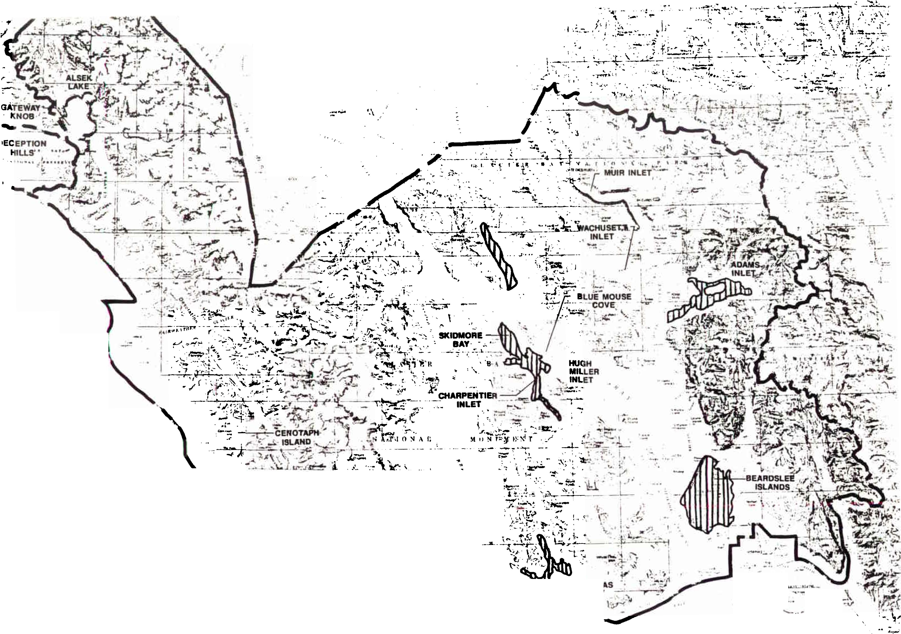s. Bartlett Cove area and road corridor

- WILDERNESS MANAGEMENT

- WILDERNESS ZONES
Nearly all wilderness lands and waters will be designated the pristine zone. The pristine zone will be subdivided into approximately 30 management units (see Figure 3), each typically including a segment of shore and associated upland watersheds.
The non-wilderness marine waters will not be included in this zone and management of these areas will be addressed in a vessel management plan to be developed later. Therefore, even though the non-wilderness marine waters are shown in figurE three as part of the individual management units they will not be guided by this plan.
Lands within a one-mile radius of the camper drop-off sites will be considered the threshold zone. This zone will shift each time a new drop-off site is designated and a previous onE is discontinued. Somewhat more concentrated use will be allowed for the purposes of wilderness access, within limits compatible with a wilderness experience in the adjacent pristine zone.
Zone boundaries may be modified from time to time an experience indicates.
  - Resource Conditions
Pristine

Resource management will adhere to the following standard. Over the majority of the area resource effects from visitor use will not be apparent. Individual campsites will be used no more than 25% of the time during the June 1 to August 31 summer season.
Disturbance to campsite vegetation and soils can be healed in one fallow year. Human effects on animal distribution, abundance, and behavior will be too slight to be biologically significant.
Within the pristine zone there will be 10 or less specific sites used more heavily than could be tolerated and still maintain the above conditions. These sites will change from time to time as visitor patterns change. Therefore the sites and standard for them will be identified in the annual wilderness operating plan in the appendix.
Threshold

Some impacts are apparent, although the area maintains a predominantly natural appearance. Individual campsites may be used on 100% of the nights during the visitor season.
Vegetational and soils impacts may be considerable during a given visitor season, but drop-off activity should be rotated no less
6

,..
..
,
< u' ,. .
....... - (:'. .,
...
.. ,, ...

,....
r .r.
,.,. I.
· ..- '
.. _}.T...
i,
·:I'

I
N

Figure 3

o.._1_..:.. ""'0 ==1.5K
0 1 fO 15MIIN

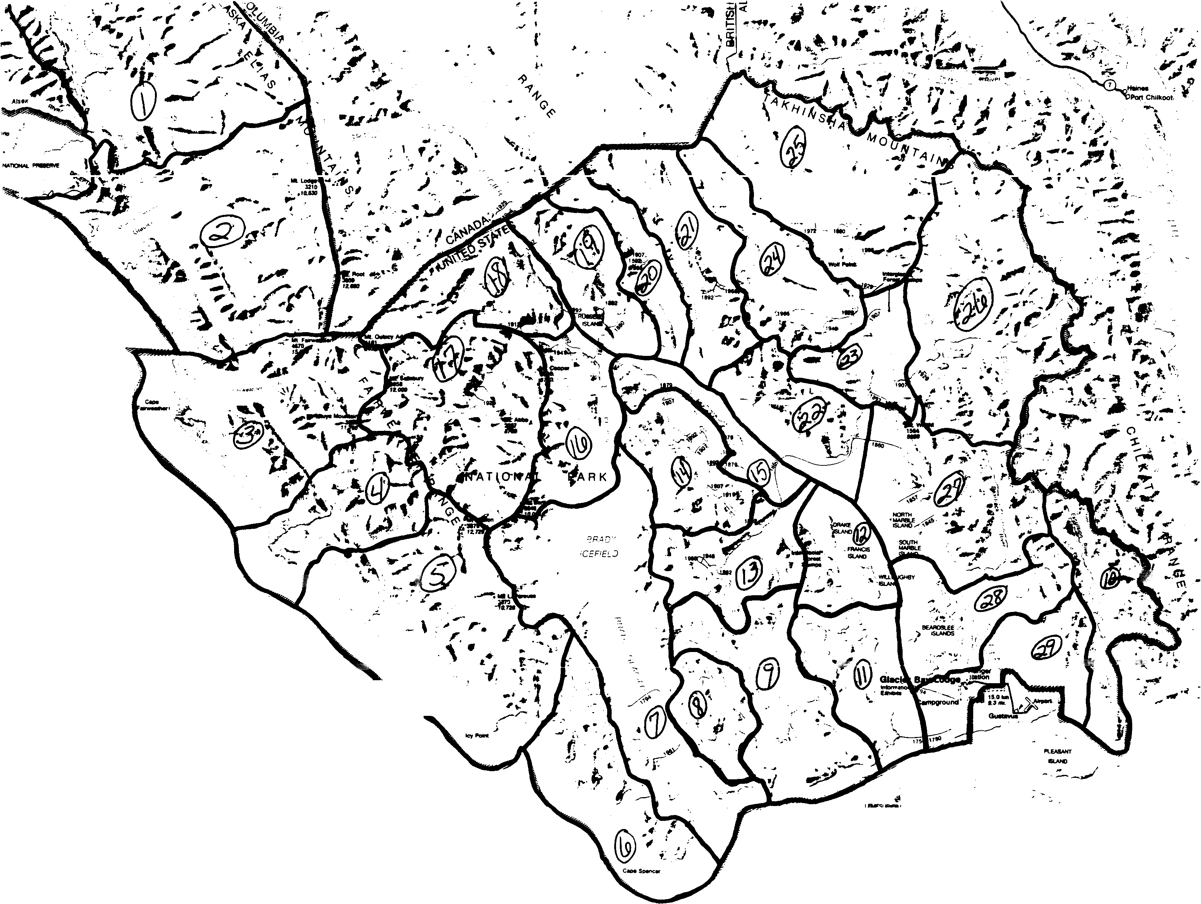
!•

- Alsek 15. Bluemouse
- Grand Plateau 16. Reid
- Fairweather 17. Hopkins
- Lituya 18. Tarr
- LaPerouse 19. Russell
- Torch 20. Rendu
- Taylor 21. Queen
- Upper Dundas 22. Tidal
- Lower Dundas 23. Lower Muir
- Excursion 24. wachusett
- Berg 25. Upper Muir
- Whidbey 26. Adams
- Geikie 27. Sandy
- Hugh Hiller 28. Beardslee
29. Bartlett
.,..'
- '
• .., -

GLACIER BAY NATIONAL PARK WILDERNESS MANAGEMENT ZONES

frequently than every two years, and should not be resumed until recovery is complete. Significant wildlife habitat may be preempted on a given year. Some seasonal displacement of wildlife may occur.
- Social Conditions
Pristine

Over the majority of the area, inter-group contacts will be rare (no campsite encounters per night and one or less travel encounters per day for 90% of the visitors). Visual evidence of previous use will be nearly absent. Close contacts with motorized craft will be rare (in and adjacent to wilderness waters) or occur on no more than 50% of the days for 90% of visitors (elsewhere).
At the few sites within the pristine zone designated yearly for heavier use, inter-group contacts will still be infrequent (no more than one campsite encounter per night and two travel encounters per day for 90% of visitors). Visual evidence of previous se will be unobtrusive. Close contact with motorized craft may occur on most days.
On all sites, camping will be out of sight and sound from other groups.
Threshold

Inter-group contacts are common (two or less campsite encounters and three or less daily travel encounters for 90% of visitors). Parties distance themselves insofar as possible for other parties, but this may not always be out of sight or earshot.
Visual evidence of previous use may be common and evident. Motorized vessels and aircraft frequent the area in order to discharge and pick up passengers.
- Management Conditions
Pristine

Over the majority of the area, management will seldom be evident. Off-site education, area closures and access manipulation will be the primary modes of visitor management. On the few sites designated for heavier use, patrol personnel and such management tools as signs may be occasionally encountered.
Threshold

NPS presence is frequent, for purposes of site management, education and enforcement.

7

- FACILITIES
  - Visitor Facilities
At this time, improved campsites are neither necessary nor desirable. The maintenance of existing trails (Bartlett River, Forest Loop, and Bartlett Lake trails) near the Bartlett Cove developed site will occur. The Bartlett Cove campground provides developed camping sites. No other trails are recommended for construction or maintenance. Hundreds of miles of shoreline make this wilderness boundary uniquely different, particularly in its accessibility by motorized craft. Cross country travel offers high quality wilderness solitude and adventure.
No shelters, pit toilets, fire grills, bear proof lockers, or other facilities will be constructed in the backcountry.
  - Administrative Facilities
Currently, administrative facilities located in or immediately adjacent to park wilderness include one radio repeater site (two other park operated sites are located on Chichagof Island in Tongass National Forest and in the Deception Hills, Glacier Bay National Preserve), a floating ranger station and fuel barge, floating research station, a weather monitoring station on Russell Island, and aids to navigation maintained by the US Coast Guard and other federal agencies.
A number of cabins and other structures constructed prior to inclusion of the area within the former monument are also located in park wilderness.
The necessity for these and possibly other future minor improvements will be reviewed from time to time.

Wilderness access in Glacier Bay National Park is provided by tour boat drop-offs, charter and private vessels, and aircraft. Drop-offs and pick-ups by the daily tour boat in Glacier Bay proper is the most frequently used means of access. The same vessel provides drop-offs for campers and a day tour for the majority of the passengers. The operating agreement between the National Park Service and Glacier Bay Lodge provides for a limited number of stops per day (currently three) for drop-offs and pick-ups from the day tour boat, since the schedule is tight. A separate camper drop-off boat remains a future possibility, though vessel entries and economics are presently precluding this option. Limited drop-off service is also provided by the overnight tour boat based at Bartlett Cove, and could be provided by tour boats based outside the park.
8

The tour boat drop-off/pick-up points will be reviewed annually and listed in the annual wilderness operating plan (appendix D). Access points will be provided to both arms of Glacier Bay proper and will be rotated at least every two years, if possible, to reduce impacts at specific sites. The park has developed criteria for systematically evaluating the potential of tour boat drop-off sites.
The National Park Service has determined that motorized vehicle, aircraft and vessel use in designated wilderness lands and waters would detract significantly from the quality of wilderness experience available to the visitor. For this reason regulations were drafted that would close various areas to such motorized use. The regulations have not been approved for publication at this time. When the regulations are finalized, they will be included in the annual wilderness operating plan.

- VISITOR MANAGEMENT
  - Group Size
Group size will normally be limited to 12 people per group. For guided parties, the limit of 12 includes guides and clients. The limit of 12 may be adjusted downward in specific zones or for specified periods of time if necessary primarily in order to protect particularly environmentally sensitive areas or wildlife.

The Superintendent may occasionally, under special circumstances, approve a party size larger than 12 for a particular group. In such cases the Superintendent may specify the location of campsites, route of travel, timing, or other restrictions in order to protect environmental values or the experience of other park users. A larger party size will not be granted unless the group agrees to comply with these directions. Approval for groups larger than 12 will be a rare exception.
Group size limitations will be mandatory and legally enforced, rather than being just recommendations as in the past.
  - Group Spacing
It is recommended that groups camp out of sight and sound of one another to the maximum extent possible and far enou9h apart so as not to intrude on the experience of other park users. This common courtesy may become mandatory and legally enforceable in the future if voluntary compliance is not adequate. Though some groups may desire a social experience in the backcountry, designated Wilderness will be managed first and foremost for wilderness dependent use, per the management objectives in this plan.

9

  - Stay Limit
No group or individual will remain longer than three consecutive nights in the same campsite, and shall make a substantial move to a new campsite after that time. This mandatory restriction is intended to prevent long term occupancy of campsites other groups may wish to use, minimize campsite deterioration and disruption of wildlife use patterns. Exceptions may be granted where these adverse impact can be avoided.
  - Orientation and Registration
Orientation and registration for backcountry users is strongly encouraged but will continue to be on a voluntary basis at this time. The park will continue to make a comprehensive effort to contact visitors before they travel into the backcountry. The objectives of this orientation and registration are:
    - Provide an update on safety and camping closures, particularly related to bears and other wildlife, and record expected return dates and obtain information necessary if a search and rescue should become necessary.
    - Provide information on minimum impact camping practices.
    - Orient visitors. Help them plan a more enjoyable trip by providing a general orientation to the park and help distribute use.
    - Collect information about the number of backcountry users and their activities, destinations, etc. necessary to properly manage the park.

The park will make a maximum effort to accomplish these objectives without requiring a mandatory permit for non­ commercial backcountry users. However, if the voluntary approach proves inadequate or the number of backcountry users increases to levels requiring limitations on the number or distribution of users, a mandatory permit will be required.
  - Regulations and Closures
Glacier Bay's environment is undergoing rapid natural change. Man's influences often seem minor when compared to those caused by natural forces. Sites where continual geologic changes occur, such as glacier outwash formation, slope wasting, and ocean scouring, tend to mitigate human use effects. The majority of use is currently centered at Ptarmigan Creek and Reid Glacier, sites that are not highly susceptible to biologic impacts. The same use levels could not be sustained in more fragile areas such as sand barren meadows, seabird colonies, or wildlife traveling and browsing ranges.
Varying degrees of protection will be needed to insure natural life processes prevail throughout park wilderness. In most areas, the instruction in minimum impact camping practices and low level dispersed visitor use should be sufficient. Some of the minimum impact camping practices, such as those currently pertaining to the preservation of natural and cultural resources, food storage, fires, sanitation and refuse, and pete; are mandatory and legally enforceable by inclusion in the code of federal regulations or compendium.
In some areas, regulatory closures to limit use may be required. The option to close areas and restrict visitor use will be exercised when necessary to ensure that the activity or area is being managed in a manner compatible with the purposes for which the park was established and shall comply with the requirements of 36 CFR 13.30.
Current regulations and closures are described in the annual wilderness operating plan (appendix D).

- GUIDE ACTIVITY
Commercial guide services for sea kayaking, backpacking/ hiking and mountaineering/ ski touring have been authorized by the park to provide necessary and appropriate visitor services in the area, or parts of the area, covered by this plan. All of the recommendations and requirements in this plan apply to commercial guide services as well as the general public. Additional conditions are included in each company's commercial authorization to operate in the park. The following additional limitations are necessary in order to maintain a proper balance between commercially guided and private trips within the park:
  - Sea Kayaking Guide Service - Glacier Bay Proper
Within Glacier Bay proper, additional limitations apply to guided sea kayaking trips as follows. A maximum of 24 guided sea kayaking trips are authorized from June 1 - September 10. A maximum of three guided sea kayaking trips may be operated at the same time within Glacier Bay proper. The concessioner will be encouraged to have trip leaders and guides that are knowledgeable about the natural history of the park and provide ample opportunity for visitors using this service to earn about the park both through structured and informal discussion.
  - Backpacking/ Hiking
In the past backpacking within the former Glacier Bay National Monument was authorized under a single permit issued to Alaska
11

Discovery, though there was no limit on the number of trips this company could operate.
This plan provides for a change in that there will be no limit on the total number of guided backpacking trips or the number of companies authorized to offer this service at this time. A maximum of three guided backpacking/ hiking trips will be authorized per company per year. A maximum total number of authorized trips for all companies will be set at a later date, when a limit becomes necessary. Within Glacier Bay proper, guided backpacking/ hiking parties may only use beach areas for camping on the first and last night of each trip. The intent of this is to authorize guided backpacking in lightly used backcountry areas away from the beach. Within Glacier Bay proper, the beach zone already receives substantial use from other park visitors.
If access via marine waters to an area within the park is necessary to begin a guided backpacking/ hiking trip, it must be provided by a company presently authorized to provide that access in Glacier Bay National Park, ie tour boat, charter boat, sea kayaking, .or air taxi operator. Due to heavy use by other backcountry users in Reid Inlet, guided backpacking parties may not use Reid Inlet for access between May 15 and September 15.
  - Mountaineering/ Ski Touring
Mountaineering is distinguished from backpacking by the primary objectives of the trip, area used, and by the use of equipment such as ropes, ice axes, crampons and other mountaineering equipment. Ski touring is included with mountaineering because glacier ski trips are the type of skiing in which a commercial interest has been expressed. Commercial mountaineering/ ski touring will be authorized within the area east of, and not including, the Fairweather Range and the boundary between wilderness zone 19 and 20, as depicted in Figure 4.
There will be no limit on the total number of guided mountaineering/ ski touring trips or the number of companies authorized to offer these services at this time. A maximum of three guided mountaineering/ ski touring trips will be authorized per company per year. A maximum total number of authorized trips for all companies will be set at a later date, when a limit becomes necessary.
If access via marine waters to an area within the park is necessary to begin a guided mountaineering/ ski touring trip, it must be provided by a company presently authorized to provide that access in Glacier Bay National Park, ie tour boat, charter boat, sea kayaking, or air taxi operator. Due to heavy use by other backcountry users in Reid Inlet, guided mountaineering/ ski touring part may not use Inlet for access between May 15
12

BRADY ICEFIELD

Norin FIGURE 4
CD

0"- 1'=.,,,,;;,,,S==1 0==-15Kllometeno

ICY

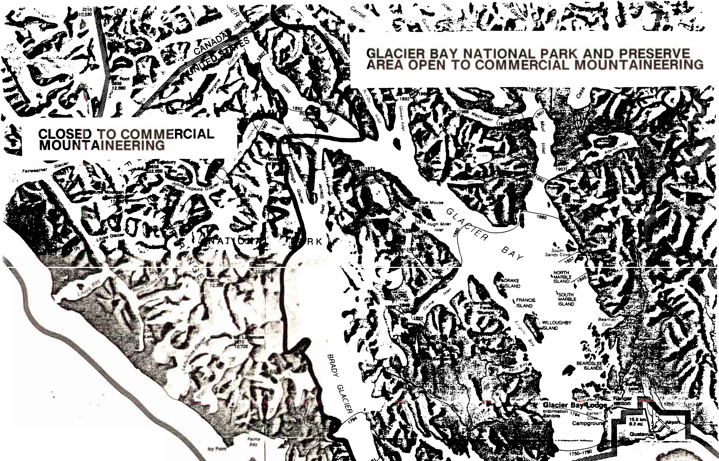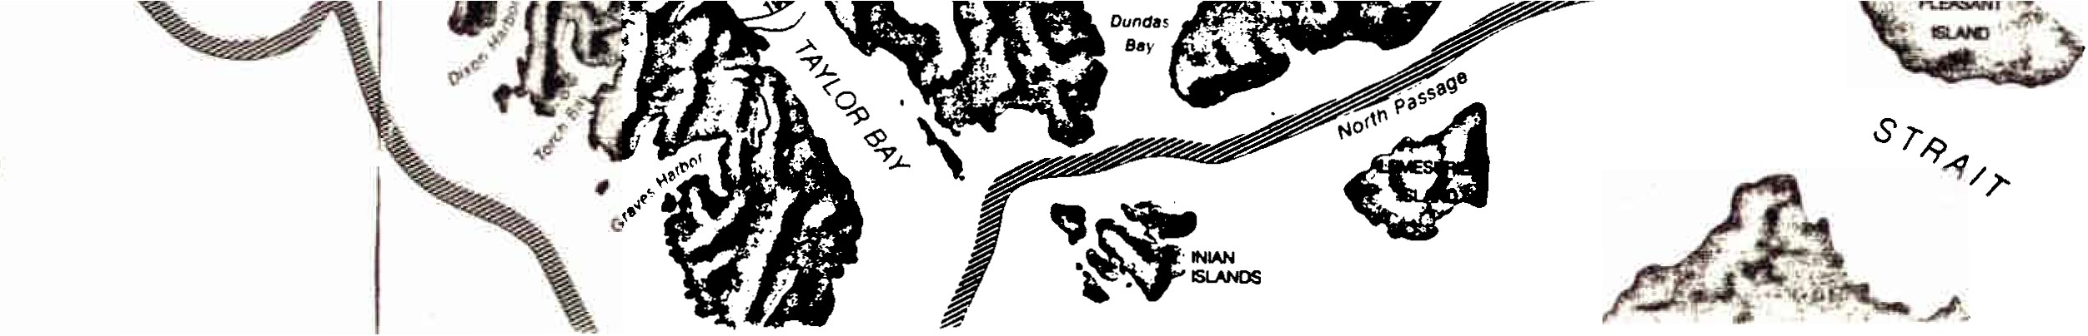o.....'...
===s"'===,,;.;'0 = '5"'/,...

. ...

passage
south .

and September 15.
  - Other Authorized Guide Services
Guided photography, guided sport fishing, charter boats and air taxis are authorized in portions of the area covered by this plan.

- RESOURCE MANAGEMENT
  - Resource Inventory
The establishment of sound wilderness management practices is dependent upon information gathering. Research data and basic inventory information contribute to the understandi11g of park resources and the effects that visitor use activities may have on park values. The review of existing data and acquisition of new baseline data are essential in identification of critical wildlife habitat. These areas will be monitored for alteration of populations of key plants and animal species. Indications of significant disturbance to biological life cycles, would lead to the limiting of visitor activity during critical periods.
A resource inventory and monitoring program was initiated in 1987 in the Beardslee Islands, Adams Inlet, and Hugh Miller Inlet wilderness waters. Continued long-term monitoring will be conducted at those locations with the identification of indicator species. The Glacier Bay Resource Management Plan identifies many specific ecological research needs useful for backcountry management planning. Resource monitoring and research projects include:
- Bear habitat use monitoring
- Establishment of a backcountry climate monitoring station
- Wilderness campsite resource inventory and impact monitoring
- Marine mammal wildlife and seabird populations monitoring
- Carrying capacity determination
- Air quality monitoring of cruise ship stack emissions

- Campsite Monitoring
At present camper related impacts within the park are limited. However, as backcountry use levels increase, areas will receive greater impact. A program of campsite monitoring has been
13

established to provide baseline information on impact at backcountry sites. The monitoring will also inform managers of the success or failure of the various controls included in this plan and form a basis for making adjustments when necessary.
The current campsite monitoring program is being improved and expanded. The present descriptive system gathers the following information:
  - Campsite location (schematic drawing) Number and distribution of sites
Frequency of use

  - Site resources (describe Area of level ground Fresh water sources Boat anchorages
site)
Fishing opportunities Scenic qualities Beach landing/access

  - Ecological conditions (photograph site) Exposure/topography
Plant communities(% ground cover)
Wildlife composition, population, and distribution Essential habitat (ie., eagle nests)
Soil characteristics
  - Impact of previous use
    - Short term
Human Waste Trash (amount) Water quality
Crowding
Development (fire rings, rock walls)
    - Long term
Soils (% bare ground) Vegetation (exposed roots) Wildlife behavior modification Historical site
Foot paths
More precise measurements will be required in heavily used sites. In these sites, the subject estimates will be backed with reproducible quantitative field measurements whenever possible.
Written instructions and on-site training will be given to insure that information specific to Glacier Bay's ecosystem is included in the campsite monitoring (see appendix A).
At specific sites, photographic records from fixed points will be made twice a year, in a systematic manner to provide documentation of severity, and various surveys will be conducted in the vicinity of the campsite to determine present conditions.
For instance, sampling and analysis of water quality of streams and lakes adjacent to campsites will estabnlish baseline data.
14

There should be no measurable long term (more than 48 hours) degradation of water quality as a result of human activity. In order to evaluate observed conditions, campsite use data needs to be determined from the backcountry use registration system.
The emphasis will be to maintain healthy, native ecosystems in campsites. Some pristine areas should be managed for no loss of ground cover. At camper drop-off sites, some loss of ground cover will be permitted, but should not exceed 100 square feet at any one site. Displacement of soil from human activity should be limited to a rate that closely approximates the natural process of erosion. Also, there should be no long term modification of natural plant succession as a result of soil compaction or vegetation trampling in areas outside campsites. Acceptable changes are those that recover in one fallow growin9 season, except in a few specified instances.
- Carrying Capacity Study
The Wilderness Act provides general guidelines for development and commercial use in wilderness. However, managers and researchers are usually left to determine acceptable levels of visitor use. Central in the philosophy for approaching this task is the concept of "carrying capacity", or use limits based on an area's ability to absorb impacts.

Carrying capacity has Managers first choose resource conditions. the actual situation,
traditionally been difficult to determine. standards for wilderness experiences and These standards are then compared against and use levels are adjusted accordingly.

Making the linkages from standards to actual conditions is difficult, expensive and time-consuming. This process is in its infancy at Glacier Bay. Though much useful information does exist, and more is in the process of development, the NPS does not yet have a thoroughly objective basis for its visitor use decisions. Given present levels of funding, objective knowledge of an appropriate kind will continue to be incomplete for a number of years. For this reason, the NPS intends to evolve working carrying capacity figures for management units, beginning with those receiving heaviest use, employing the be1;t data and management judgement available. These figures will at first be non-binding guidelines, but may become mandatory after sufficient management experience and research has accrued to them.

- BEAR MANAGEMENT

Two of Glacier Bay's primary management objectives are to preserve and maintain a wild and free-ranging bear population as an integral part of the park's natural ecosystem and to provide for the safety of park visitors. To achieve these c::>bjectives the
15

park will establish and implement it's bear management program. The Bear Management Plan and this Wilderness Visitor Use Management Plan are interrelated documents. Consideration was given to bear management objectives in formulating and developing every aspect of this plan. Some key elements of that program that are an integral part of this plan include:
  - Education and Enforcement
An active program will be implemented to inform visitors, prior to entering the backcountry, about policies, regulations and goals of the bear management program. Emphasis will be placed on communicating an awareness about proper camping techniques in bear country, how to avoid conflict, and the effects of exposing bears to unnatural food sources. This information will be provided at the visitor orientation upon arrival at Bartlett Cove, interpretive programs, and at briefings given with the issuance of backcountry permits. Regulations concerning bear feeding, improper food storage, and areas closed to public use will be strictly enforced.
  - Reduction of Unnatural Food Sources
In order to prevent bears from becoming food-conditioned or habituated, the park will continue to evaluate its strategy for eliminating unnatural food attractions in the backcountry. It will conduct research into improved means of reducing the incidence of bears getting human food. The use of bear resistant food containers/canisters may be recommended or required for all or parts of the park. The park will continue to evaluate the effectiveness of bear repellents such as capsaicin.
  - Closures
Backcountry areas may be permanently or temporarily closed to human use and/or specific activity to minimize people/bear conflict. Such closures may be instituted for the welfare of the bear, to prevent behavioral changes such as habituation or displacement due to the frequency of human use, or to increase human safety in areas of particular bear activity.
Before a closure is recommended or instituted, the park will give full consideration to the impact of closure on backcountry use.
It will first consider all voluntary or less restrictive means of obtaining the same objectives.
Because of the effect of tour boat drop-off sites in dispersing backcountry use, bear activity will be a major factor in their selection.

16

  - Statistics and Monitoring
An effort will be made to maintain a computerized monitoring system of bears observed on a daily basis by employees and visitors. Case incident forms will be used for all reports of property damage, management actions, dead bears, confrontations, human injuries, and property damage. The system will be used to provide current management data as an essential tool in all efforts to anticipate and prevent bear problems.

- RESEARCH
The Antiquities Act under which Glacier Bay National Monument was originally set aside, the monument's enabling proclamation, ANILCA, and the Biosphere Reserve designation all recognize the importance of science in Glacier Bay. Research conducted in park wilderness will generally comply with all wildernes1; requirements but case by case exceptions may be made to allow appropriate projects to proceed. Research proposals are routinely reviewed for their effects on wilderness and general park visitors as well as scientific merit. Authorization has been granted in the past for the use of motorized equipment, seasonal base camps, site markers or cairns, and the collection of specimens. These activities will continue, where necessary and appropriate.
Research activities are beyond the scope of this plan, but will be balanced with other wilderness uses and natural resource preservation.

17

- CONSISTENCY WITH OTHER PARK PLANS, USES

This Wilderness Visitor Use Management Plan deals with an important, though limited, aspect of the overall management of the park. Briefly, this section describes how the plan is linked, or relates, to other aspects of park management.
The broad outlines of wilderness management are described in the Glacier Bay General Management Plan, which was approved in September 1984. The current plan is consistent with, and subsidiary to, the general management plan (see Table 1 - typical NPS planning documents).
In 1988 the NPS conducted a statewide review of all areas in the national park system in Alaska that are not already designated wilderness to determine their suitability or non-suitability for preservation as wilderness. The Glacier Bay wilderness review and this management plan were developed concurrently as separate documents. There are no apparent reasons why this plan would be incompatible with additional wilderness that may be designated as a result of the wilderness review. However, application of this plan to newly designated wilderness in Glacier Bay should be reviewed if the existing wilderness boundaries are altered.
Two issues closely related to wilderness management which were of concern to those commenting on the draft plan were vessel and aircraft management. Most of the vessel restrictions currently in place relate to the protection of humpbacks whales, an endangered species. A vessel management plan will be developed in the future to address what level of vessel use would produce an unacceptable negative impact on the visitor experience or adversely impact other marine mammals, seabirds, or other wildlife populations. Two vessel restrictions of particular interest that are currently in place on a year-round basis are the limits of two cruise ships and three tour boats per day. See "regulations and closures" section of this plan for additional discussion of vessel restrictions applicable to wilderness.
The park recognizes the substantial intrusion on the wilderness experience caused by aircraft. Although aircraft provide some backcountry access, the vast majority of flights are scenic overflights for cruise ship passengers from Haines, Skagway and Juneau. Half a dozen companies operate a substantial number of flights over the park. The National Park Service has no authority to manage the air space over the park.. The park will work with air taxi operators to make them aware of the impact of their operations on the park, views expressed by park visitors concerning overflights, and seek to guide overflights to areas which would be less disruptive to park visitors and wildlife while maintaining an excellent experience for air taxi passengers. See "regulations and closures11 section of this plan for additional discussion of current Federal Aviation
18

Administration advisories to pilots concerning flight over noise sensitive areas, including national parks.

19

The NPS will review and analyze information from the ongoing monitoring program and other changes which may necessitate updating or modifying this plan. The plan was written so as to give park managers some flexibility in responding to changing conditions. Some issues such as registration, a cap on the number of commercial mountaineering trips, modification of zone boundaries, and others include some of the future actions which may be necessary if the current plan proves inadequate. These future actions are within the scope of the existing plan and may be adopted without revising the plan. The wilderness visitor use management plan presents the general concepts which are expected to guide visitor use for 5 to 10 years. An annual operating plan in the appendix includes detailed information that is subject to change on a more frequent basis, such as tour boat drop-off points, seasonal closures, etc.
If significant future changes are necessary, the plan will have to be modified. In this case plan modifications and the rationale for them will be made available for public comment.
turn.

APPENDIX C

MINIMUM IMPACT CAMPING GUIDELINES

In Glacier Bay, it is still possible to discover areas that appear untouched by man. Help keep it that way by minimizing your impact on the area. Enjoy the backcountry and make a special effort to leave this great natural area unblemished.
Check in at the Bartlett Cove visitor contact station before heading out. The park staff will provide you with .information on bears, current area closures, tour boat schedules, ,:1.nd specifics about the area you intend to visit.
Locating a Campsite
In nearly all of the park, you may camp where you w,:1.nt. However, camping is prohibited:
-within 100 feet of a stream or lake
-within 1/4 mile of the shoreline of Bartlett Cove or the park road except at the campground
-on certain bird nesting islands; and,
-in areas closed because of bear problems.
Watch for signs of wildlife traveling, feeding, resting or raising young. Choose a campsite where there is low wildlife usage, so that you won't displace animals from important parts of their habitat.
Naturally disturbed places such as outwash fans, beach scour zones and areas where thickets are encroaching make the best campsites. Mature forests and thickets are next best.
Particularly wet or dry plant communities are easily damaged by trampling.
Out of respect for other backcountry users and wildlife, keep your camp and activities as inconspicuous as possible. Locate back from the water. Tall vegetation or small hills will reduce visibility and noise substantially. Use earth-colored clothes and camping gear. If other parties are too close, move on and choose a campsite that insures privacy for you and others.
Pre_paring a Meal
Avoid smelly or poorly packaged foods that might unduly attract bears to the vicinity. Cook a minimum of 100 yards from sleeping areas. Beaches are excellent sites for food preparation and dishwashing, since tides will disperse food scraps and odors.
All food, garbage and cooking or food storage equipment (not being transported, consumed or prepared for consumption) must be:
- at forested sites - suspended in a tree at least 10 feet up

and 4 feet out from the trunk.
- at unforested sites - stored at least 100 yards from a camp, inside closed containers.
Look for signs of bear activity, and always put your food in a place they have not been frequenting.
Stoves are strongly recommended in recently deglaciated areas, since firewood is scarce and smoke is very visible there. Fires must be below the high tide line on beaches, or in areas subject to flooding or scouring in the uplands. Dead wood may be burned, except for interglacial wood you find washing out of old silt or gravel deposits.
Keep a Clean Camp
Wastes decompose slowly in the cool Glacier Bay environment. The best place for recycling human manure is below the high tide line where currents can disperse it and marine organisms can reduce it to basic nutrients. Next best is in the upper soil layer beneath well developed plant communities. Burn toilet paper when possible or use natural plant material.
Fish refuse should be thrown into the sea away from your campsite.
Leave your camp "naturalized" by replacing rocks and scattering natural litter back where it was. Allow other campers a sense of discovery by leaving shells, bones, interglacial wood and rocks where you found them.
Never soap yourself, clothes or dishes directly in fresh water. Carry water 100 feet back from a stream or lake before washing.
Boil, filter or iodize your drinking and cooking water to avoid the possibility of contracting Giardiasis.

