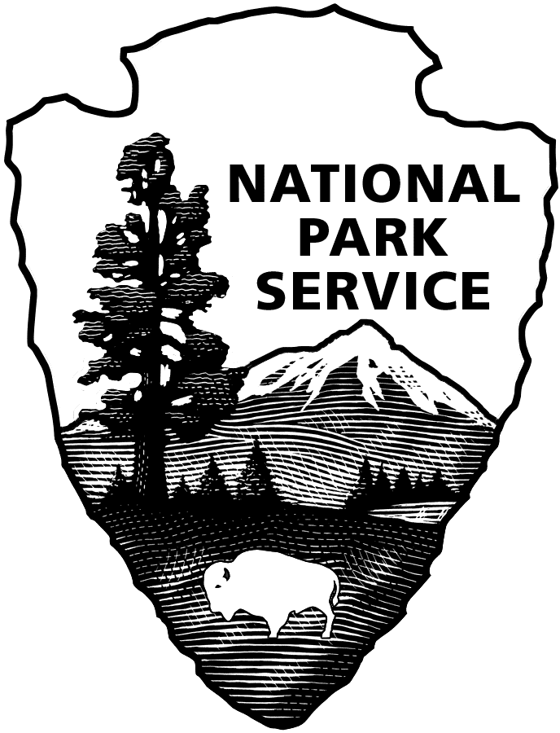
United States Department of the Interior

NATIONAL PARK SERVICE
Glacier Bay National Park & Preserve
P.O. Box 140
Gustavus, Alaska 99826-0140
Tel: (907) 697-2230

RECRUITMENT BULLETIN: GLBA-24-029
ISSUE DATE: April 17, 2024
CLOSING DATE: May 01, 2024

JOBS AVAILABLE THROUGH THE ALASKA LOCAL HIRE PROGRAM--PUBLIC LAW 96-487

Glacier Bay National Park and Preserve is accepting applications for two, temporary not-to-exceed 1039 hour, full-time, Park Ranger (Interpretation), GS-0025-05 positions. More than one position may be filled via this bulletin.
________________________________________________________________________________

POSITION DUTY LOCATION
Park Ranger (Interpretation), GS-0025-05 Bartlett Cove, AK
$21.42 to $27.85 per hour, plus a 3.21% Cost of Living Allowance (COLA)

APPOINTMENT INFORMATION: Temporary, full-time approximately mid-June to early September. The appointment may be extended for an additional period (not to exceed 1039 hours total employment). Persons selected may be eligible for rehire in future years. Schedule may involve weekend work or performance of duties before or after “normal” working hours. Government housing is not available. More than one position may be filled from this posting.

BENEFITS: Temporary, seasonal, and intermittent employees on appointments expected to last at least 90 days, and expected to work a schedule of 130 hours or more a calendar month, will be eligible to enroll in a Federal Employee Health Benefit (FEHB) health plan upon notification from their employing office. Eligible employees will be responsible for the employee share of the premium while on the official agency roles, which will be deducted from bi-weekly earnings.

DUTIES: You will work as a Park Ranger (Interpretation), GS-0025-05 at Glacier Bay National Park and Preserve. Duties include but are not limited to the following:

Park ranger – interpreters connect people to parks. They play a key role in ensuring that visitors have a meaningful, satisfying, and safe park experience, help visitors decide how to spend their time in the park, and inform them about the wonders that await their discovery. Park ranger – interpreters are specially trained to engage the public so that each park visitor can find a personal connection with the meanings and values found in the places and stories of that park. They help visitors explore the many dimensions of parks by introducing them to a variety of perspectives. By providing the opportunity for visitors to care about the places they visit, they promote stewardship and the opportunity for those visitors to care for park resources.

National parks are among the most remarkable places in America for recreation, learning, and inspiration. The work done by park ranger-interpreters through effective interpretive and educational programs encourages the development of a personal stewardship ethic and broadens public support for preserving and protecting park resources, so that they may be enjoyed by present and future generations.”

PHYSICAL DEMANDS: The work involves extensive periods of standing and walking, in some cases over rough surfaces or inclines, carrying backpacks, tools, rescue equipment, etc.

WORK CONDITIONS: The work is performed in settings in which there is regular and recurring exposure to moderate discomforts and unpleasantness, e.g., high or low temperatures, confined spaces or adverse weather conditions.

WHO MAY APPLY: Any U.S. citizen who has acquired special knowledge or expertise regarding the natural or cultural resources of Glacier Bay National Park and Preserve, by reason of having either lived or worked in or near the park. To be eligible, applicants must have lived or worked in or near the area long enough to encounter and become familiar with a full range of typical conditions that affect the work to be accomplished. Applicants’ resumes should reflect periods of time having lived or worked in or near the area of consideration.

Areas considered “near” Glacier Bay National Park and Preserve are Icy Bay on the north to Dixon Entrance on the south, Gustavus, Hoonah, Elfin Cove, Pelican, Excursion Inlet, Haines, Skagway, Juneau-Douglas-Auke Bay, Yakutat and Dry Bay.

POSITION REQUIREMENTS: Requirements will be determined by evaluating experience in your resume and /or in the interview and selection process. All position requirements must be met by the closing date of this job posting. Knowledge or expertise concerning the park’s or preserve’s natural and/or cultural resources and the management thereof is required. Local knowledge of the resources and the typical conditions that affect the work to be accomplished will be applied in the performance of the duties. In determining eligibility, applicants' resume must indicate periods of time of having lived and/or worked in or near the above listed areas of consideration. Failure to do so may result in non-referral of your application.

Following are nine identified for this position. Applicants are not required to address these competencies in a separate document but are encouraged to include in their resume’s information related to these competencies.

- Basic knowledge of interpretive principles, practices, techniques, and themes to develop and
- Present formal and informal audience and learner-centered interpretive experiences using well established and commonly known interpretive skills, techniques, and tools; and ability to prepare and deliver structured and informal presentations that are clearly consistent with the strategic goals and objectives of interpretation.
- Basic knowledge of the natural, cultural, and recreational resources and history of the specific park assigned.
- Knowledge of visitor facility/center operations to perform the routine activities of a visitor facility and/or information desk, and provide assistance in coordinating day-to-day operations.
- Ability to promote safety principles and practices that ensure a safe park environment.
- Ability to assist in coordinating special projects.
- Ability to track, report, and review visitor use statistics for trends.
- Ability to effectively communicate orally in order to present ideas and information that increase understanding of NPS programs, policies, and objectives.
- Ability to utilize common computer programs and applications (e.g., word processing, databases, spreadsheets, and other software systems) for publishing content to websites and social media sites. Must be able to apply computer skills in the operation of various automated systems and databases.

CONDITIONS OF EMPLOYMENT:

- U.S. Citizenship required.
- Appointment subject to background investigation with favorable adjudication before starting work.
- Selectee will be required to participate in the Direct Deposit Electronic Funds Transfer Program.
- Must be 18 years of age or older.
- Males must meet Selective Service Registration Act requirement. Verify registration at sss.gov.
- Government housing is available.
- You will be required to operate a government motor vehicle as part of your official duties; a valid driver’s license is required. After selection, you may be required to submit a GSA Form 3607 and driving record at your own expense.
- You will be required to wear a uniform and comply with the National Park Service uniform standards. A uniform allowance will be provided.
- You may be required to work on-call, evenings, weekends, holidays, overtime and shift work.
- You must be physically and mentally able to climb a ladder during a moving transfer from vessel to cruise ship.

HOW TO APPLY:

PLEASE READ THE FOLLOWING INSTRUCTIONS CAREFULLY! Incomplete submissions may result in non-referral of your application. Please note: An application consists of your resume and any other required forms or documents outlined below. There is no application form to complete.

Assistance may be obtained by e-mailing glba_hr@nps.gov.

All applications must be postmarked or received via email by the closing date of the announcement.

If mailed via USPS, your application must be addressed to: Park Headquarters, Glacier Bay National Park and Preserve, P. O. Box 140, Gustavus, AK 99826.

If your application is postmarked on the closing date, it must be received in a sealed envelope at Glacier Bay National Park and Preserve no later than seven calendar days after the closing date. Emailed applications must be received by 11:59 AKST on the closing date of the job posting.
It is the applicant’s responsibility to verify their application has been received via email by the deadline specified above.

You may email your application to: glba_hr@nps.gov. Emailed applications must not be sent (CC) to this position’s supervisor or any other individual staff member.

If you email your application, include the bulletin number in the subject line. If you apply for more than one position, send a separate email with application for each position.

Note: Information provided in the body of the email will not be considered part of your application. Include all information you want to share in your resume or include a cover letter.

Be sure to not include any photographs of yourself or any PII (Personally Identifiable Information), such as your Social Security Number, driver’s license number, or passport number.

Hand-delivered applications cannot be accepted. DO NOT SEND your application via UPS or FedEx. We do not accept faxed applications or applications mailed in postage-paid government envelopes or through an internal government mail system.

REQUIRED FORMS to send via USPS or email:

- Resume that provides detailed information about your work experience. Also include: the recruitment bulletin number of the position for which you are applying; and for each period of employment: the dates worked (for example, June 2009 through August 2010), the position title, employer’s name, phone number and address.
  - Emailed resumes and cover letters need to be sent as attachments.

- DD-214 if claiming points of Veterans’ Preference; if claiming 10 points of Veterans’ Preference, also include the SF-15 and verification documents described on the back of the SF-15. The SF-15 may be obtained through the Internet at www.opm.gov/forms.

It is the applicant’s responsibility to provide documentation/proof of claimed status for veterans’ preference, qualifications, and education. Applicants will not be solicited for further data if that provided is found to be inadequate, illegible, or incomplete.

Application materials will not be returned; therefore, do not submit original documents that you may need in the future, or extra materials such as letters of recommendation, photographs, or award certificates.

If you make a false statement in any part of your application, you may not be hired or you may be fired after you begin work, or you may be subject to fines, imprisonment, or other disciplinary action.

Veterans’ Preference (for qualifying veterans): To receive Veterans’ Preference, your application package must include a legible copy of the DD-214, “Military Discharge,” that shows the type of discharge from service (usually the Member 2 or 4 copy), or Report of Separation from Active Duty if separation was prior to July 1, 1979. If claiming 10-point Veterans’ Preference, you also must provide a completed SF-15 (www.opm.gov/forms) and verification documents listed on the SF-15. If you are separated and as yet do not have a DD-214, you may use an official statement of service from your command indicating that you have completed active service and are being discharged under honorable conditions, or provide other official documentation (e.g. documentation of receipt of a campaign badge or expeditionary medal) that proves your military service was performed under honorable conditions. You will not receive Veterans’ Preference if you do not provide this documentation.

Reasonable Accommodations: The agency provides reasonable accommodations to applicants with disabilities where appropriate. If you need a reasonable accommodation for any part of the application and hiring process, please notify the park office listed on this announcement. Determinations on requests for reasonable accommodations will be made on a case-by-case basis.

Privacy Act Information The application you submit for this position contains information subject to the privacy act of 1974 (PL-93-579, 4 USC 552a). We are required to provide you with information regarding our authority and purpose for collecting this data, the routine uses which will be made of it and the effects, if any, of non-disclosure. You are entitled to the same information as it pertains to disclosure of your social security number. Any questions you may have regarding the Privacy Act regulations and the rights it extends can be answered by contacting the park office.

Equal Employment Opportunity Appointments are made without regard to race, color, age, sex, sexual orientation, religion, political affiliation, national origin, marital status, non-disqualifying handicap condition or any non-merit factor.

