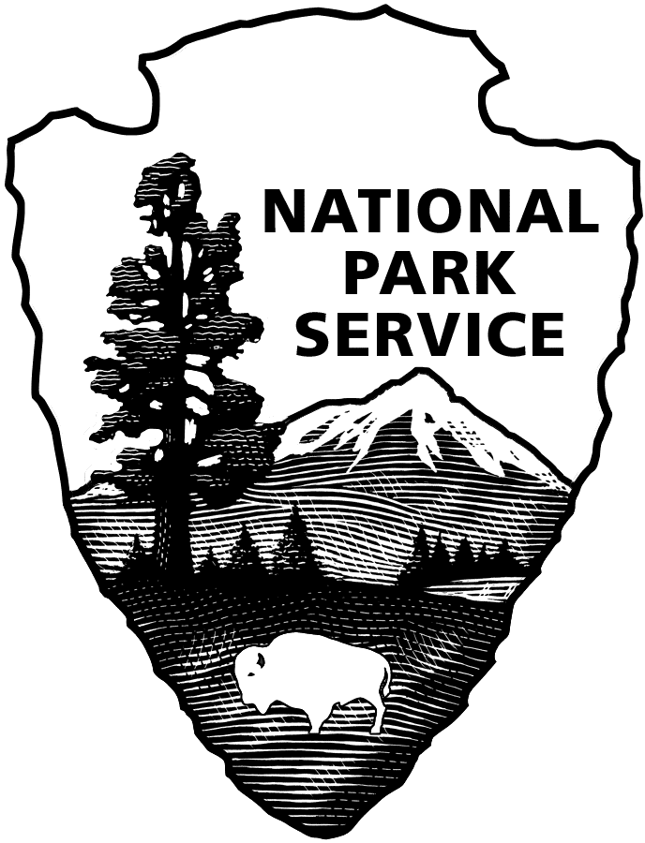
United States Department of the Interior

NATIONAL PARK SERVICE
Glacier Bay National Park & Preserve
P.O. Box 140
Gustavus, Alaska 99826-0140
Tel: (907) 697-2230

RECRUITMENT BULLETIN: GLBA-24-016
ISSUE DATE: April 08, 2024
CLOSING DATE: April 22, 2024

JOBS AVAILABLE THROUGH THE ALASKA LOCAL HIRE PROGRAM--PUBLIC LAW 96-487

Glacier Bay National Park and Preserve is accepting applications for one, permanent, full-time, Maintenance Mechanic Supervisor, WS-4749-09 position.
________________________________________________________________________________

POSITION DUTY LOCATION
Maintenance Mechanic Supervisor, WS-4749-09 Bartlett Cove, AK
$45.83 to $53.46 per hour

APPOINTMENT INFORMATION: Permanent, full-time. Employees can be converted to the competitive service after two years of satisfactory service in the same appointment, and upon meeting all regulatory requirements. Competitive service enables employees to compete for other career opportunities through announcements that are open to current permanent career or career conditional Federal employees.

BENEFITS: Insurance, Retirement, Thrift Savings Plan (similar to a 401K) with matching Government contributions; paid holidays, annual and sick leave; performance-based longevity pay increases.

DUTIES: You will work as a Maintenance Mechanic Supervisor, WS-4749-09 at Glacier Bay National Park and Preserve. Duties include but are not limited to the following:

Serves as a working supervisor that is capable of performing basic roads, trails, and fleet maintenance activities, heavy equipment operation, and equipment repairs. Roads Maintenance activities include leveling, grading, and adding fill to gravel roads, asphalt repair, striping, drainage management, road sign repair, and preservation of the road prism. Road maintenance activities in the winter primarily consist of snow removal. Trails and Grounds Maintenance activities include vegetation trimming, roadside brushing, hazard tree removal, wooden boardwalk repair, and graded surface repair. Summer trails activities include supervision of trails maintenance at Glacier Bay Preserve at Dry Bay, AK, a remote site accessible by plane only. Vehicle and Vessel Maintenance activities include diagnosis, overhaul, repair and service of gasoline and diesel-powered equipment and associated electrical, hydraulic, and mechanical systems. Vehicles maintained include passenger vans, trucks, Neighborhood Electric Vehicles (NEV), All-Terrain Vehicles (ATVs), Utility Terrain Vehicles (UTVs), and equipment such as graders, loaders, back hoes, dump trucks, fuel trucks, and skid-steers. Vessels maintained include skiffs, Research and Law Enforcement boats, landing crafts, a pilot boat, and a 90-foot research vessel. Heavy Equipment Operation: Operates heavy equipment on occasion to remove snow, move heavy objects, and perform grounds and roads maintenance.

PHYSICAL DEMANDS: Frequently lifts and carries items weighing up to fifty pounds, and often puts forth similar effort in pushing, pulling, turning, and positioning parts, assemblies, equipment and tools.

WORK CONDITIONS: Works both inside and outside. When working inside, worker is frequently exposed to drafts, changing temperature, and noise. When working outside, worker is frequently exposed to bad weather. Often works in rain, mud and snow and cold temperatures. Icy, slippery conditions are normal for six months of the year.

WHO MAY APPLY: Any U.S. citizen who has acquired special knowledge or expertise regarding the natural or cultural resources of Glacier Bay National Park and Preserve, by reason of having either lived or worked in or near the park. To be eligible, applicants must have lived or worked in or near the area long enough to encounter and become familiar with a full range of typical conditions that affect the work to be accomplished. Applicants’ resumes should reflect periods of time having lived or worked in or near the area of consideration.

Areas considered “near” Glacier Bay National Park and Preserve are Icy Bay on the north to Dixon Entrance on the south, Gustavus, Hoonah, Elfin Cove, Pelican, Excursion Inlet, Haines, Skagway, Juneau-Douglas-Auke Bay, Yakutat and Dry Bay.

POSITION REQUIREMENTS: Requirements will be determined by evaluating experience in your resume and /or in the interview and selection process. All position requirements must be met by the closing date of this job posting. Knowledge or expertise concerning the park’s or preserve’s natural and/or cultural resources and the management thereof is required. Local knowledge of the resources and the typical conditions that affect the work to be accomplished will be applied in the performance of the duties. In determining eligibility, applicants' resume must indicate periods of time of having lived and/or worked in or near the above listed areas of consideration. Failure to do so may result in non-referral of your application.

Following are five competencies identified for this position. Applicants are not required to address these competencies in a separate document but are encouraged to include in their resume’s information related to these competencies.

- Serves as a working supervisor that can perform basic roads, trails and fleet maintenance activities, heavy equipment operation and equipment repairs.

- Roads Maintenance: Competent in leveling, grading, and adding fill to gravel roads, asphalt repair, striping, drainage management, road sign repair, snow removal and preservation of the road prism.

- Trails Maintenance: Competent in vegetation trimming, roadside brushing, graded surface, wooden boardwalk, puncheon, turnpike and bog bridging construction and repairs.

- Fleet Maintenance: Competent in diagnosis, overhaul, repair and routine service of gas, diesel and electric powered equipment and associated electrical, hydraulic, and mechanical systems. Equipment maintained and repaired includes passenger vehicles, light, medium and heavy-duty trucks, ATVs, UTVs, heavy equipment and vessels ranging small outboard powered skiffs to 90-foot research vessels.

- Heavy Equipment Operations: Competent in snow removal, moving heavy objects, roads and grounds maintenance.

CONDITIONS OF EMPLOYMENT:
- U.S. Citizenship required.
- Appointment subject to background investigation with favorable adjudication before starting work.
- Selectee will be required to participate in the Direct Deposit Electronic Funds Transfer Program.
- Selectee will be subject to a two-year trial (probationary) period.
- If you are a new supervisor in the Federal government, you will be required to complete a one-year supervisory probationary period.
- Must be 18 years of age or older.
- Males must meet Selective Service Registration Act requirement. Verify registration at sss.gov.
- You may be required to travel up to 10 nights per month. You must obtain a government charge card for travel purposes.
- The National Park Service has determined that the duties of this position are suitable for telework and the selectee may be allowed to telework with supervisor approval.
- You may be required to complete training and obtain/maintain a government charge card with travel and/or purchase authority.
- You must be able to obtain and maintain a current valid driver’s license with CDL B with Hazmat and Tanker endorsements within 6 months of employment.
- You will be required to possess a current medical certification.
- Government housing is not available.
- You will be required to submit to a drug test and receive negative drug test results prior to appointment. In addition, this position is subject to random testing for illegal drug use.
- You may be required to operate a government motor vehicle as part of your official duties. Prior to your first official motor vehicle operation, and again every year thereafter (or more frequently if management determines such need exists), you will be required to sign an affidavit certifying to your possession of a valid State issued driver's license that is current and has not been revoked, suspended, canceled, or otherwise disqualified in any way to prohibit your operation of a motor vehicle. You will also submit a photocopy of your valid State issued driver's license prior to your first official motor vehicle operation, and again every year, or more frequently if management determines such need exists. Lastly, you may be required to submit (within a State sealed envelope or submitted directly by the State authorities), and at your own expense, all certified driving records from all States that discloses all valid driver's licenses, whether current or past, possessed by you. Please indicate in your application whether you possess a valid State driver's license.
- You will be required to wear a uniform and comply with the National Park Service uniform standards. A uniform allowance will be provided.

HOW TO APPLY:

PLEASE READ THE FOLLOWING INSTRUCTIONS CAREFULLY! Incomplete submissions may result in non-referral of your application. Please note: An application consists of your resume and any other required forms or documents outlined below. There is no application form to complete.

Assistance may be obtained by e-mailing glba_hr@nps.gov.

All applications must be postmarked or received via email by the closing date of the announcement.

If mailed via USPS, your application must be addressed to: Park Headquarters, Glacier Bay National Park and Preserve, P. O. Box 140, Gustavus, AK 99826.

If your application is postmarked on the closing date, it must be received in a sealed envelope at Glacier Bay National Park and Preserve no later than seven calendar days after the closing date. Emailed applications must be received by 11:59 AKST on the closing date of the job posting.
It is the applicant’s responsibility to verify their application has been received via email by the deadline specified above.

You may email your application to: glba_hr@nps.gov. Emailed applications must not be sent (CC) to this position’s supervisor or any other individual staff member.

If you email your application, include the bulletin number in the subject line. If you apply for more than one position, send a separate email with application for each position.

Note: Information provided in the body of the email will not be considered part of your application. Include all information you want to share in your resume or include a cover letter.

Be sure to not include any photographs of yourself or any PII (Personally Identifiable Information), such as your Social Security Number, driver’s license number, or passport number.

Hand-delivered applications cannot be accepted. DO NOT SEND your application via UPS or FedEx. We do not accept faxed applications or applications mailed in postage-paid government envelopes or through an internal government mail system.

REQUIRED FORMS to send via USPS or email:

- Resume that provides detailed information about your work experience. Also include: the recruitment bulletin number of the position for which you are applying; and for each period of employment: the dates worked (for example, June 2009 through August 2010), the position title, employer’s name, phone number and address.
  - Emailed resumes and cover letters need to be sent as attachments.

- DD-214 if claiming points of Veterans’ Preference; if claiming 10 points of Veterans’ Preference, also include the SF-15 and verification documents described on the back of the SF-15. The SF-15 may be obtained through the Internet at www.opm.gov/forms.
- Current Commercial Driver’s License (CDL) Class B with tanker endorsements and no air brake restrictions, if already in possession.
- Current Medical certificate, if already in possession.

It is the applicant’s responsibility to provide documentation/proof of claimed status for veterans’ preference, qualifications, and education. Applicants will not be solicited for further data if that provided is found to be inadequate, illegible, or incomplete.

Application materials will not be returned; therefore, do not submit original documents that you may need in the future, or extra materials such as letters of recommendation, photographs, or award certificates.

If you make a false statement in any part of your application, you may not be hired or you may be fired after you begin work, or you may be subject to fines, imprisonment, or other disciplinary action.

Veterans’ Preference (for qualifying veterans): To receive Veterans’ Preference, your application package must include a copy of the DD-214, “Military Discharge,” that shows the type of discharge from service (usually the Member 4 copy), or Report of Separation from Active Duty if separation was prior to July 1, 1979. If claiming 10-point Veterans’ Preference, you also must provide a completed SF-15 (www.opm.gov/forms) and verification documents listed on the SF-15. If you are separated and as yet do not have a DD-214, you may use an official statement of service from your command indicating that you have completed active service and are being discharged under honorable conditions, or provide other official documentation (e.g. documentation of receipt of a campaign badge or expeditionary medal) that proves your military service was performed under honorable conditions. You will not receive Veterans’ Preference if you do not provide this documentation.

Reasonable Accommodations: The agency provides reasonable accommodations to applicants with disabilities where appropriate. If you need a reasonable accommodation for any part of the application and hiring process, please notify the park office listed on this announcement. Determinations on requests for reasonable accommodations will be made on a case-by-case basis.

Privacy Act Information The application you submit for this position contains information subject to the privacy act of 1974 (PL-93-579, 4 USC 552a). We are required to provide you with information regarding our authority and purpose for collecting this data, the routine uses which will be made of it and the effects, if any, of non-disclosure. You are entitled to the same information as it pertains to disclosure of your social security number. Any questions you may have regarding the Privacy Act regulations and the rights it extends can be answered by contacting the park office.

Equal Employment Opportunity Appointments are made without regard to race, color, age, sex, sexual orientation, religion, political affiliation, national origin, marital status, non-disqualifying handicap condition or any non-merit factor.

