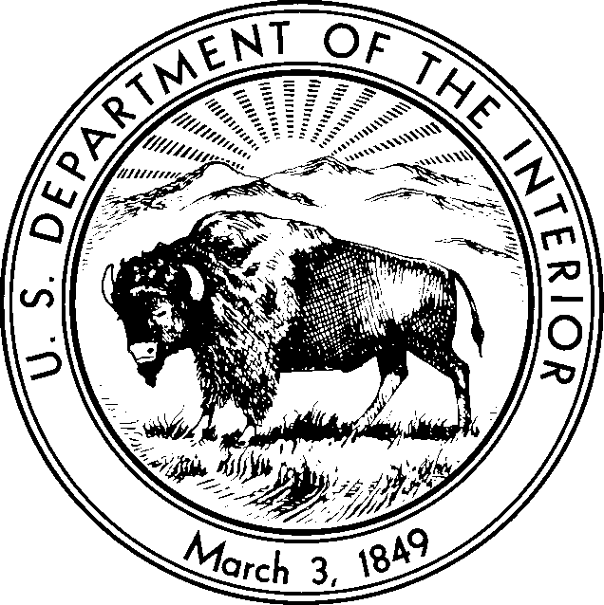
United States Department of the Interior
NATIONAL PARK SERVICE
National Capital Region National Capital Parks - East 1900 Anacostia Drive SE Washington, DC 20020

Record of Determination for the Temporary Closure of Fort Dupont Park Roads
for the 2024 Implementation of the National Capital Parks-East White-tailed Deer Management Plan
Pursuant to 36 CFR l.5(a)(1), the National Park Service is temporarily implementing rolling closures to park roads and trails noted below. Closures will restrict all public access and travel on a case-by-case basis from 5:00 p.m. to 4:00 a.m., January 2, 2024, through April 15, 2024. The closures will be enforced to implement the approved White-tailed Deer Management Plan as described in the Environmental Impact Statement and Record of Decision. During implementation, the closures will be designated by posted signage, roadway gates, and employee and law enforcement officer direction. Violation of closures is prohibited.

Temporary closures from 5:00 p.m. to 4:00 a.m. in Fort Dupont Park include:
- Fort Dupont Drive, SE (at Randle Circle to Fort Davis Drive)
- Fort Davis Drive (from Massachusetts Avenue, SE to Ridge Road, SE)
- F Street from Minnesota Avenue, SE and spur to Ely Street
- Fort Dupont/Lanham Estates loop off Alabama Avenue
- All trails/foot and bike paths (Hiker-Biker Trail, etc.)
Temporary closures from 5:00 p.m. to 4:00 a.m. in Greenbelt Park include:
- Park Central Road
- Perimeter Trail Parking off Goodluck Road
- All trails/foot and bike paths (Perimeter and Dogwood trails, etc.)
- All picnic areas and closed campground loops
Temporary closures from 5:00 p.m. to 4:00 a.m. in Fort Washington Park include:
- Fort Washington Road
- All trails

The temporary closures are necessary for public safety when, as part of the Deer Management Plan, deer reduction actions will occur after dark. Other safety measures will also be in place to protect park visitors and neighbors. These include the use of highly trained biologists from the
U.S. Department of Agriculture who will work under the direction of National Park Service

resource management specialists and in coordination with the U.S. Park Police and local law enforcement. Implementing the plan is a critical step toward ensuring the forest can support native plants and animals in a sustainable manner for this and future generations.
The temporary closures are not of a nature, magnitude or duration that will result in a "significant alteration in the public use pattern." Other nearby roads will remain open to the public. Because deer management operations will use park roads, these roads will need to be closed to ensure public safety. Although there has been some public controversy regarding deer reduction actions, there is no controversy as to the need for these road closures and other such measures to protect park visitors and neighbors, so these closures are not of a "highly controversial nature."

Accordingly, the National Park Service determines publication as rulemaking in the Federal Register is unwarranted under 36 CFR 1.5(b). This determination is consistent with hundreds of earlier partial or temporary closures, the legal opinion of the Office of the Solicitor, and judicial adjudications that have upheld other National Park Service closures and public use limitations to include Spiegel v. Babbitt, 855 F. Supp. 402 (D.D.C.1994) affd in part w/o op. 56 F. 3d 1531 (D.C. Cir. 1995), reportedinfull, 1995 US App. Lexis 15200 (D.C. Cir. May 31, 1995); ANSWER Coalition v. Norton, No. 02-1715 (D.D.C. August 22, 2002), plaintiffs emergency motion for appeal for injunction pending appealed denied Mahoney v. Norton, No. 02-5275 (D.C. Cir.
September 9, 2002) (per curium); Picciottov United States, No. 99-2113 (D.D.C. August 6,
2000); Picciottov. Lujan, No. 90-1261 (D.D.C. May 30, 1990); and Picciottov. Hodel, No. 87-
3290 (D.D.C. December 7, 1987).
Pursuant to 36 CFR 1.5(c), 1.7, notice of this temporary closure will be made through media advisories, officer and employee directions, roadway gates, and the posting of signs at conspicuous locations in the affected park areas. Finally, pursuant to 36 CFR 1.5(c), this determination is available to the public upon request.

TARA MORRISON
Digitally signed by TARA MORRISON
Date: 2023.12.21 12:29:56 -05'00'

Tara D. Morrison
Superintendent, National Capital Parks-East

