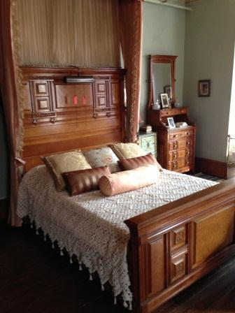
NPS PHOTO
FROM THE CURATOR'S CORNER: NEW BED LINENS AT GLENMONT
As a curator of a historic house museum, I am immediately sidetracked by obvious anachronisms within the exhibit areas when visiting other historic house museums. Webster's Dictionary defines an anachronism as "an artifact that belongs to another time." I define it as the distraction I experience when I notice the 1960s starburst linoleum in the historic turn of the century kitchen or the modern telephone in the Victorian entrance hall. In general, visitors to historic house museums are savvier than they were twenty years ago. With networks like HGTV and DIY, I suspect most can recite something they gleamed from an episode of the Antiques Roadshow or a furniture fact that they learned from the Keno brothers. I can't help but think that these visitors are noticing these obvious anachronisms too.
The National Park Service strives for historical accuracy in regards to their historic properties. This not only includes the information that is being shared with the general public but what the visitors are experiencing and seeing. At Glenmont, we have moved one step closer to achieving this goal. I am pleased to announce that a government funded PMIS project will result in the replacement of historically inaccurate, outdated bed linens and pillows in the second floor bedrooms of Thomas Edison's home, Glenmont. Bedspreads purchased from inexpensive chain stores will be replaced with ones of crewel work, satin and silk, and open work crochet. Contemporary style pillows will be replaced with reproductions of boudoir style pillows that Mina historically displayed in the bedrooms, documented by site photographs and receipts from decorating projects that took place in these rooms in the 1920s. Of particular note is the removal of the early 1970s style mustard yellow bed hangings on the canopy bed in the North bedroom. We all loved the Brady Bunch but we don't expect to be reminded of it in Thomas Edison's Queen-Anne style Victorian mansion!
An unexpected outgrowth of the work to replace the bed linens is the relationships the park has formed with women from all walks of life who are working to keep traditional methods of textile making alive for future generations. Eleni hand crafts Victorian style velvet pillows with handmade lace as a border. Another woman hand crochets a tasseled bedspread using a traditional pattern from her family, one that takes her over one year to complete. Pillow maker Wende Cragg from California, who specializes in pillows with historic Art Noveau and Arts and Crafts designs, says of her work, "Each appliqued pillow is hand cut and machine stitched without the aid of computers, very Old World/Old School! I believe I was born into the wrong century and could have been quite happy stitching away, hours on end! I've been doing this for nearly 45 years but it never gets old and I always welcome a challenge!"
Stay tuned to see all of the purchased textiles arrive at Glenmont as we begin our transformation of the West bedroom, the North bedroom, Mrs. Sloane's room, Theodore's room, and Thomas and Mina's Master bedroom.

