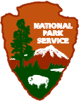
National Park Service
U.S. Department of the Interior

Carl Sandburg Home
National Historic Site
Plan a Sandburg Home ParKids! Visit

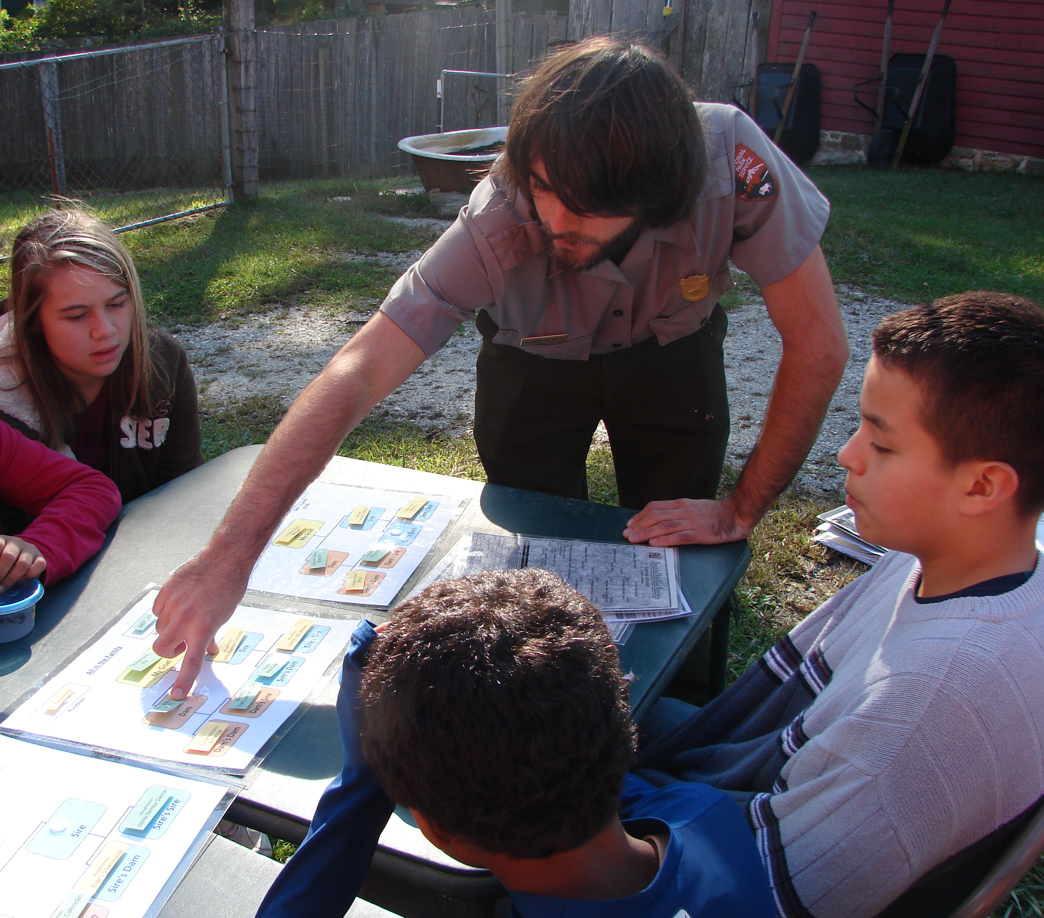
- ParKids! reservations are for youth groups with a minimum of 10 persons and a maximum of 80 persons per visit. Participants will be split into groups of 20 persons each.

- Reservations may only be made Monday – Friday. Weekend visits are subject to first come first serve policy. Please call ahead if you are planning a weekend visit.

- Please submit the request form at least three weeks before your visit. Summer reservations can fill 6-8 weeks in advance, so plan early.

- Reservations for ParKids! are accepted from mid-June through mid-August - Wed, Thurs and Friday ONLY.

- There is a $5.00 charge for house tours for adults. $3.00 for adults over age 62 and free for youth 15 and younger. Fee waivers may be granted for your group. See the fee waiver instructions on the last page.

ParKids! Activities at
Carl Sandburg Home NHS

Sandburg Summer Stage Performance
Apprentice Actors from the Flat Rock Playhouse School of the Drama perform 30 min selections from Carl Sandburg's Rootabaga Stories and biography of Abraham Lincoln. Rootabaga Express is performed Thursday and Saturday. Spink, Skabootch and Swipes is performed Wednesday and Friday. Performances are open to the public and seating is first-come first-served 10:15 to 10:45

Visiting the Barn
Tour Connemara Farm and learn about what it was like raising goats with the Sandburg family!

House Tour
Explore the home where Carl Sandburg and his family lived for 22 years! Special house rules can make the tour difficult for the wee ones, ages 8 and older only.

ParKids! Discovery Kits
Discovery backpacks are filled with easy self-led activities to make your hike fun and educational. Activities contain easy to follow instructions for any camp leader to use! Students will have the chance to use binoculars, magnifying glasses and more! .

Poetry Alive!

Bring Sandburg’s words to life through performance. Youth will explore Sandburg’s poetry, create their own choreography and perform it on stage.

Video and Bookstore
Enjoy a 6-minute animated film listening to Sandburg himself as narrator, then visit the park bokstore where you will find a variety of educational materials about Carl Sandburg, the natural environment, and literature for young people. Items priced from .49 cents and up.

Accessibility
A visit involves a lot of walking. If you have someone in your group who will need assistance, please let us know prior to your visit, a variety of options are available to help everyone fully enjoy a visit. More accessibility information can be found on our website.

ParKids! Request Form

Requestors Name: | Todays Date:
Group Name: | Age Range:
Address:
Phone: | Secondary Phone:
E-mail:

Requested date to visit: _____________________ 2nd Choice: ______________________
(play reservations are Wed, Thurs & Fri ONLY)

# of Youth (age 15 and under) ________ # of Adults (age 16 and older):_______

Planned Time of Arrival in parking lot: _____________________________________________

Does your group have any special needs (needs the shuttle from parking lot, would like to eat lunch on site, etc…) ___________________________________________________________________________

Select your requested activities below:
Select at least as many activities as you have rotations. Example: 45 visitors will need at least 3 activities scheduled; they will be divided into 3 rotations of 15 each.
Activities (30 minutes each)
    - Sandburg Summer Stage Performance 10:15
    - House Tour (age 8 and older only)
    - Barn visit
    - Hike with Discovery Kits
      - Leaf Kit
      - Fungi Kit
      - Historic Landscape Kit
      - Birds Kit
    - Ranger Led Program (variety options)
    - Sandburg Alive!

Notes:
- House tours are scheduled every 30 minutes on the quarter hour.
- To calculate how much time to plan for your visit, add up selected activities and an additional 30 minutes.

Sample Schedule with 3 rotations:

Rotation | 10:15 | 10:45 | 11:15 | 11:45 | 12:15 | Guide
A | Sandburg Summer Stage | Discovery Kit | Video/Bookstore | Barn Tour | End of rotations | Ranger
B | Sandburg Summer Stage | Barn Tour | Discovery Kit | Video/Bookstore | End of rotations | Ranger
C | Sandburg Summer Stage | Video/Bookstore | Barn Tour | Discovery Kit | End of rotations | Ranger

Fax completed forms to: Education Coordinator at (828)-693-4179
Sample Visit Itinerary
based on sample rotation schedule above:

- Arrival
- 10:00 am in main parking lot
- Assign each person to a rotation (providing the itinerary to at least one person in each rotation is a good idea)
- bathroom stop
- walk up hill or ride 12-passenger shuttle

- Sandburg Summer Stage Performance starts at 10:15 am

- Rotations begin
- 1st rotation - 10:45 am

- Conclusion
- Last Rotation ends 12:15 pm
- Return to busses/transportation by 12:15 pm

- Lunch (optional)
- carry in, carry out encouraged; limited trash services
- no concessions at park
- no place to store food; busses and coolers suggested
- Picnic area, amphitheater or house garage only, please be careful of litter

How to Apply for a Fee Waiver

To apply for a fee waiver you must be a qualified education or therapeutic organization. You may write a letter on your organization’s letterhead. Please state the learning or therapeutic objectives of your visit. For example, “Students will be able to name two issues which permeated Sandburg’s poetry after touring the home of Carl Sandburg.” Your letter must be received and approved before visiting the park.

If approved, the house tour fee will be waived for any adult and youth who visit with your group. You will be notified by e-mail, mail or phone as to the approval or denial of the fee waiver and in some cases the need for more specific objectives before the fee waiver can be approved.

You may fax your fee waiver request to: (828) 693-4179

or mail it to:
Carl Sandburg Home NHS
Attn: Fee Waiver Request
81 Carl Sandburg Lane
Flat Rock, NC 28731

