
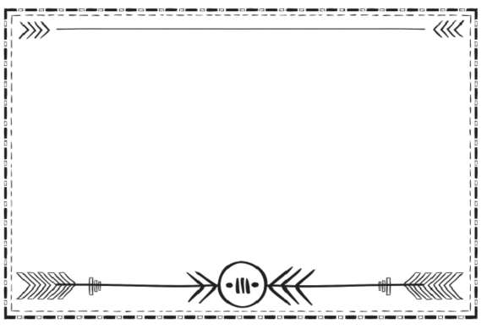
Trading Post Geometry Problem 1
- During the fur trade era, horses or oxen would have pulled this hand cart filled with trade items like blankets, furs, dried meats, clothing, and cookware.
This hand cart’s wheel diameter is 54 inches. What would its radius be?

Work Space
Hand cart
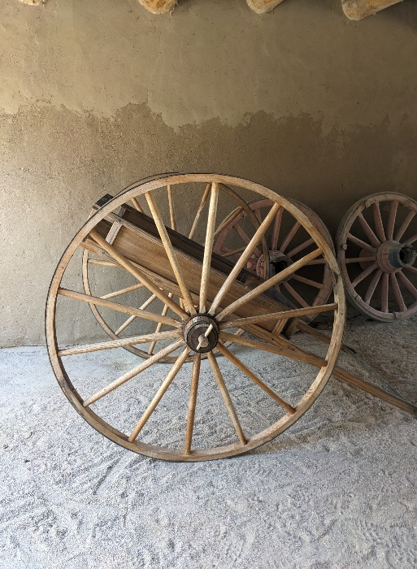

Trading Post Geometry Problem 2
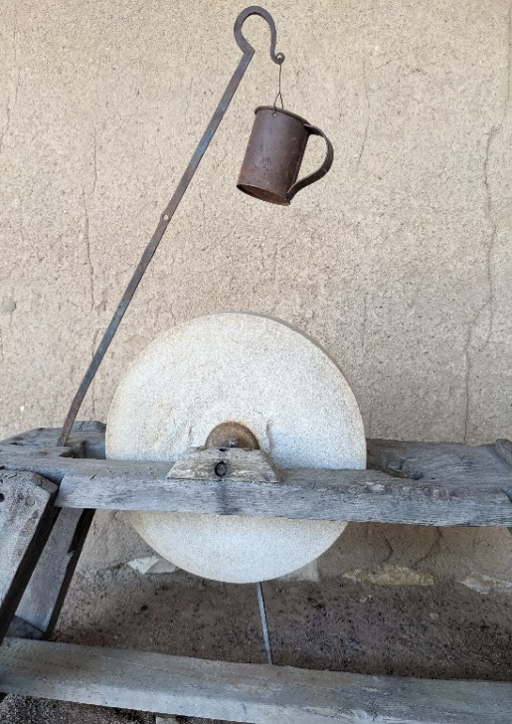
2. A grinding wheel was used to sharpen tools and blades such as knives and axes. At Bent’s Fort carpenters and blacksmiths would have used this tool regularly.

The radius of this stone wheel is 16”. What is its diameter?

Grinding wheel
Work Space

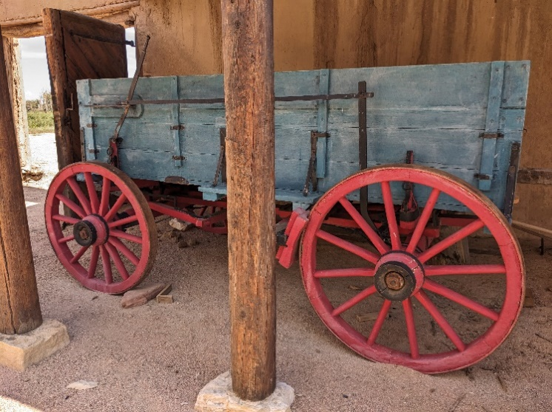
Trading Post Geometry Problem 3
Dearborn wagon
3. This Dearborn wagon differs from the hand cart by having four wheels instead of two. The Dearborn also offered seating for the riders.
The larger back wheel has a radius of 20”. What would the area of the back wheel be?

Work Space

Trading Post Geometry Problem 4
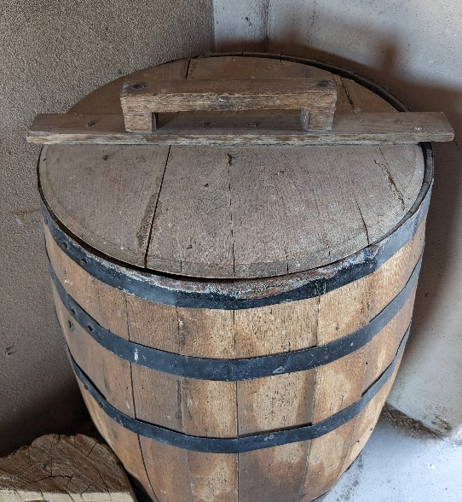
4. A wooden barrel like this would have had many uses at a trading post. Dry goods like flour, peaches, dried apples, or liquids like water would have been stored in them.
The lid on this barrel is 21” in diameter. What is the lid’s circumference?
Wooden barrel
Work Space

Trading Post Geometry Problem 5
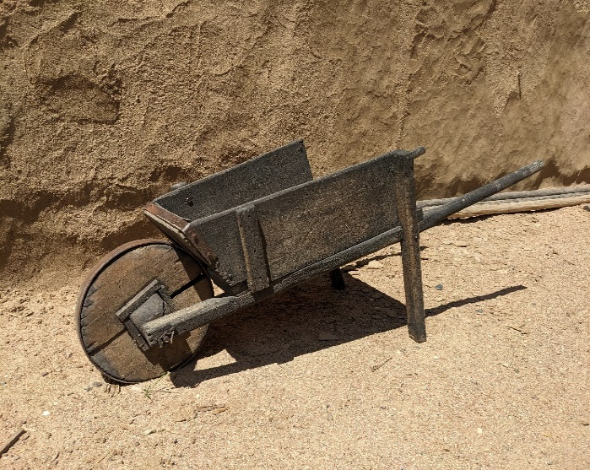
Work Space
5. A wheelbarrow like this one was likely used by Mexican adobe masons to build the fort. Sand, straw, and clay was gathered up and mixed with water to form bricks.
The diameter of the wheel is 15”. What would the wheel’s area be?
Wheelbarrow

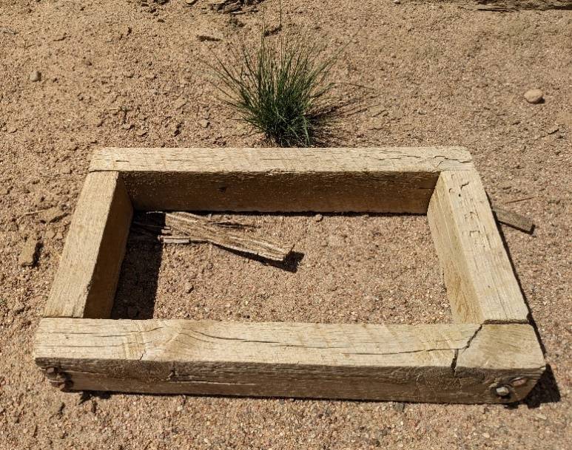
Trading Post Geometry Problem 6
Adobe brick frame
6. Bent’s Fort was built in 1833 by adobe masons contracted from Mexico. At the time there were no other adobe constructions in the region. The mixture of sand, clay, and straw was placed into this frame and left out in the sun to dry and harden into bricks.
The frame measures 9” x 17”. What is the area of an adobe frame?
Work Space

Trading Post Geometry Problem 7

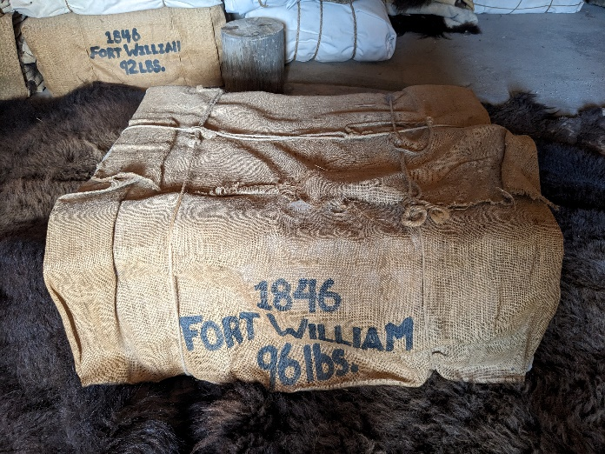
Work Space
7. Buffalo robes were the primary trade item at Bent’s Fort. Because they were so bulky, they were pressed and baled to make shipping easier. About ten robes made up a bale. This bale measures 33” long, 25” wide, and 14” high. A bale is roughly the shape of a rectangular prism.
What is this bale’s cubic volume?
Buffalo robe bale

Trading Post Geometry Problem 8

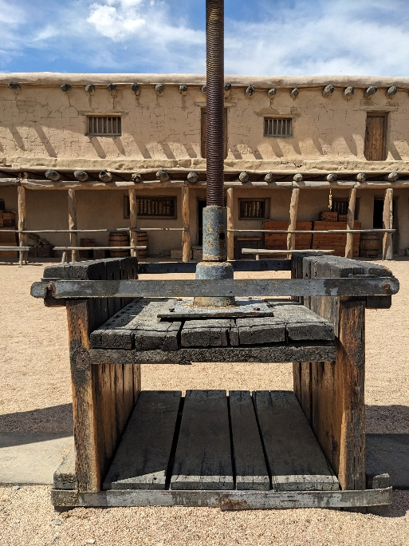
Work Space
8. This fur press would have been used to squeeze and flatten several thick and bulky buffalo robes. Once the space was filled, robes were pressed tightly, tied together, and baled.
The floor space in the press measures 27 ½ inches by 29 inches.
What is the area of the fur press floor?
Fur press

Trading Post Geometry Problem 9

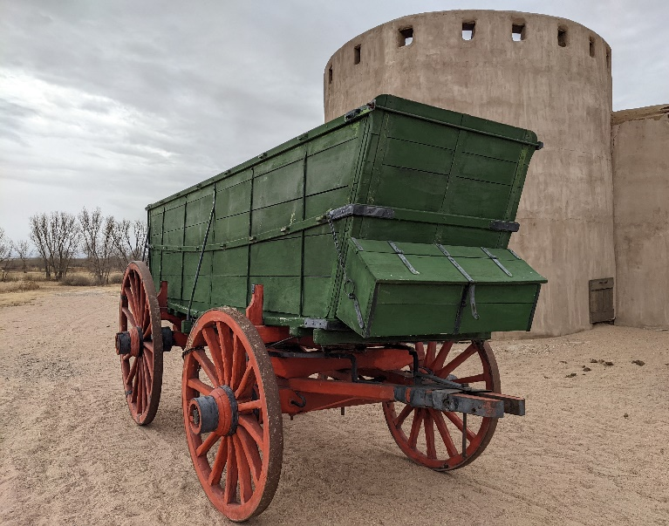
Work Space
9. Many different trade items were transported in a Conestoga wagon. At Bent’s Fort buffalo robes would have been loaded in great numbers. Thousands of them were carted along the Santa Fe Trail and traded to markets further away. The bed of a Conestoga measures approximately 12 ft x 16ft x 3.5ft. What is the cubic volume of a Conestoga wagon bed?
*Bonus question* Approximately how many bales of buffalo robes might fit into the bed of a Conestoga? (See answer to buffalo robe bale question to help calculate.)
Conestoga wagon

Trading Post Geometry Problem 10

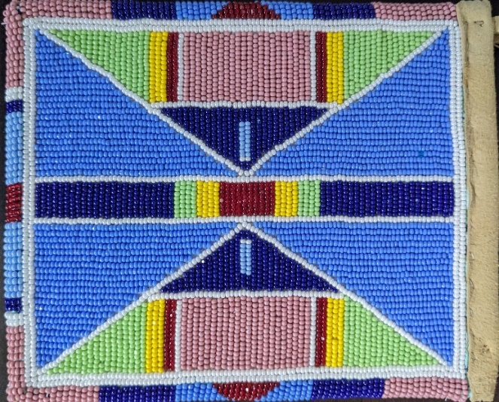
10. This pouch with glass beads and hide was created by the Apsáalooke/Crow Nation of the Northern Plains. Historically, many Plains tribes would trade hides and furs for glass beads at Bent’s Fort. This type of pouch is used for carrying small items like herbs. Imagine how long it took a native beader to create!
Look closely at the traditional designs and their colors. What types of angles do you see? Find one angle, draw it, and name the type it is.

Work Space
Crow beaded pouch

Trading Post Geometry Problem 11

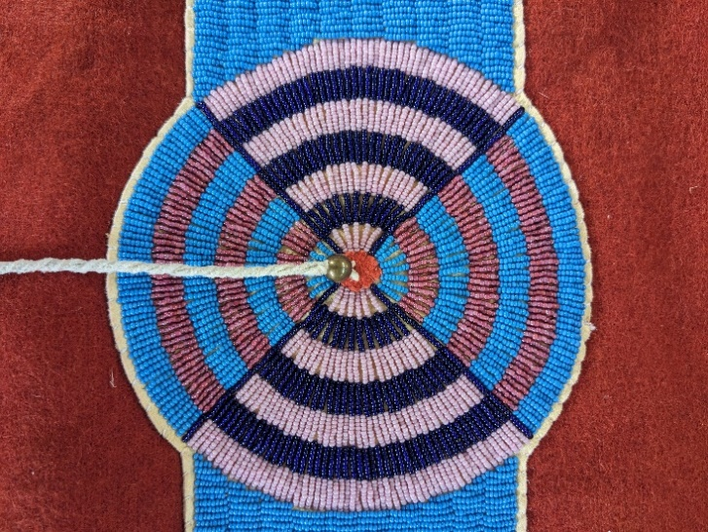
Work Space
11. This Plains style blanket is defined by a beaded strip that includes a circular design with different colored beads. Tribes obtained this cloth through trade at Bent's Fort. This type of cloth was used to make other forms of clothing.

What types of angles are the top and bottom sections (bright blue and rose) or the left and right sections (dark blue and pink) forming?
What types of angles are side by side (top and right or bottom and left)?
What is the sum of all four angle measurements?
Plains Style Trade Cloth Blanket

Trading Post Geometry Problem 12
Lakota tipi bag
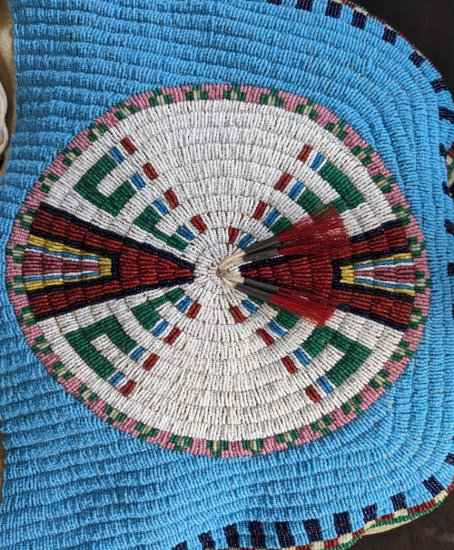
Work Space
12. This brained-smoked tanned hide-Lakota tipi bag created with glass beads incorporates a traditional circular design. The intricate pattern is adorned with horsehair and metal cones. At Bent's Fort, tribes historically obtained trade beads through trading and used them on their traditional crafts like this tipi bag. Tipi bags were traditionally made by Plains tribes to transport belongings between encampments and are still made today by tribal members. Native American artists continue the tradition of bead work that requires great skills and knowledge. (See task below.)

- Measure the degree of the angle formed by the dark red read outlined in black. Draw an angle with the same measurement below. What kind of angle is it?

- What would you call the pair of dark red angles at the top and bottom of this design?

Trading Post Geometry Problem 13
13. A wooden wagon wheel is able to form many different types of angles between its spokes.
Choose a few sections to measure and shade in to form an acute angle. Label it.
Choose a few sections to measure and shade in to form an obtuse angle. Label it.
Draw a border around a complementary angle and label it.
Draw a border around a supplementary angle and label it.
Wagon wheel
Work Space
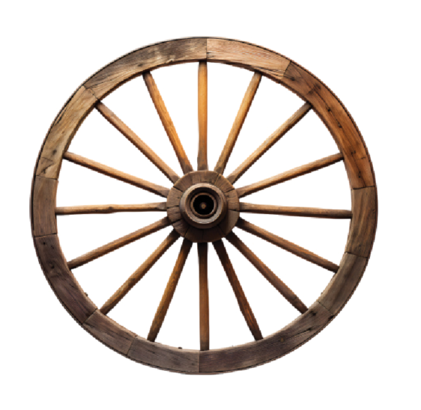

Trading Post Geometry Story Problem Answer Key

1. Hand cart radius is 27 inches.
2. Grinding wheel diameter is 32 inches.
3. Area of the Dearborn wagon back wheel is 1,256 inches ² .
4. Wooden barrel lid circumference is 65.94 inches.
5. Wheelbarrow wheel’s area is 176.71 inches ² .
6. Adobe frame area is 153 inches ² .
7. Buffalo robe bale volume is 11,550 inches ³ or 6.68 ft ³ .
8. Fur press area is 797.5 inches ² .
9. Cubic volume of Conestoga wagon bed is 672 feet ³ .
Approximate number of buffalo robe bales to fit in a Conestoga
wagon is 100.
10. Types of angles on a Crow beaded pouch: straight angles, acute
angles, right angles, obtuse angles, adjacent angles,
complementary angles, supplementary angles.
11. Types of angles on top/bottom, right/left are opposite angles.
Types of angles next to each other top/right, bottom/left are
supplementary angles.
12. Dark red angle is acute and approximately 30 degrees. The pair
of angles would be opposite angles.
13. Answers will vary.

